**Foodservice Distribution Industry**

**FY2023/24 Financial Statements Analysis**

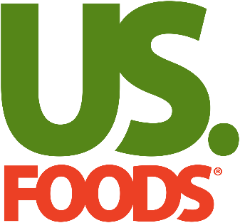

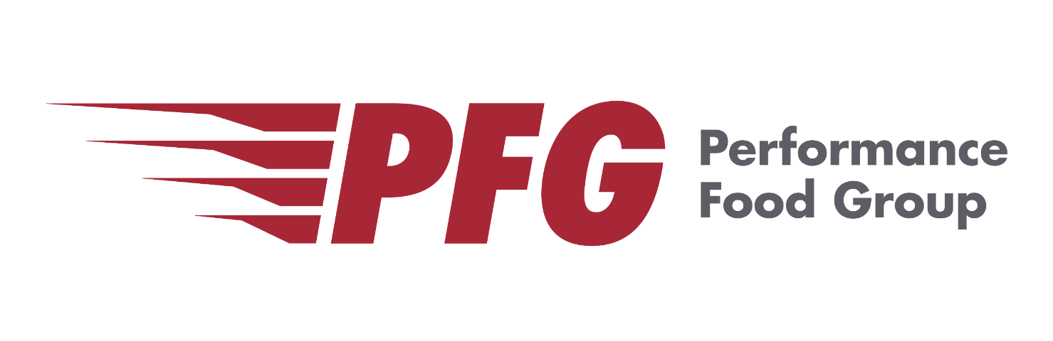

Seiji Hirano

Last Updated on 1/16/2025

Table of Contents

Report Overview & Background 6

Description 6

Methodology 6

Industry Overview 6

Business Model 6

Top Companies by Market Cap 7

Industry Trend 7

Common Risk Factors 8

Financial Ratio Industry Comparison (2023/2024) 9

Profitability 9

2024 9

2023 9

Liquidity 9

2024 9

2023 10

Solvency 10

2024 10

2023 10

Activity 10

2024 10

2023 11

Valuation 11

2024 11

2023 11

Key Highlights 11

Key Players Horizontal Analysis 12

Sysco Corporation 12

Employees & Labor Relations 12

Business 12

Property 12

Stock Performance Graph 13

KPIs 13

Balance Sheet Chart 14

P/L Chart 14

Cash Flow Chart 15

Historical Financial Ratios 15

Long-Term Debt (Most Recent Years) 16

Maturities of Long-Term Debt / Estimated Debt Service Requirements 16

Key Financial Insights 17

US Foods 20

Employees & Labor Relations 20

Business 20

Property 21

Stock Performance Graph 22

KPIs 22

Balance Sheet Chart 23

P/L Chart 23

Cash Flow Chart 24

Cash Flow Chart – Relative to Sysco 24

Historical Financial Ratios 25

Long-Term Debt (Most Recent Years) 25

Maturities of Long-Term Debt / Estimated Debt Service Requirements 26

Key Financial Insights 26

Performance Food Group (PFG) 28

Employees & Labor Relations 28

Business 28

Key Risk Factors Unique to PFG 28

Property 29

Stock Performance Graph 29

KPIs 29

Balance Sheet Chart 30

P/L Chart 30

Cash Flow Chart 31

Cash Flow Chart - Relative to Sysco 31

Historical Financial Ratios 32

Long-Term Debt (Most Recent Years) 32

Maturities of Long-Term Debt / Estimated Debt Service Requirements 32

Key Financial Insights 33

Final Notes 34

Supplemental Data 35

Sysco Corporation 35

KPIs by Segment 35

Historical Balance Sheet with % of Total 35

Historical Balance Sheet with % Change 36

Historical P/L Statement 36

Historical Equity Statement 37

Historical Cash Flow Statement 39

US Foods 40

KPIs by Segment 40

Historical Balance Sheet with % of Total 40

Historical Balance Sheet with % Change 41

Historical P/L Statement 41

Historical Equity Statement 42

Historical Cash Flow Statement 43

Performance Food Group 44

KPIs by Segment 44

Historical Balance Sheet with % of Total 44

Historical Balance Sheet with % Change 45

Historical P/L Statement 45

Historical Equity Statement 46

Historical Cash Flow Statement 47

DuPont Analysis (2024) 48

Sysco Corporation 48

US Foods 48

Performance Food Group 48

Sysco Corporation 49

US Foods 49

Performance Food Group 49

Financial Ratios Formula 50

Activity Ratios 50

Liquidity Ratios 51

Solvency Ratios 51

Profitability Ratios 52

Valuation Ratios 52

# Report Overview & Background

## Description

This report is designed to provide a detailed overview of the food distribution industry.

## Methodology

This report primarily relies on data from each company’s financial statements but also incorporates information from online resources.

# Industry Overview

## Business Model

A foodservice distribution business acts as an intermediary between food producers (manufacturers, farmers, processors, etc.) and foodservice establishments (restaurants, hotels, schools, hospitals, etc.).

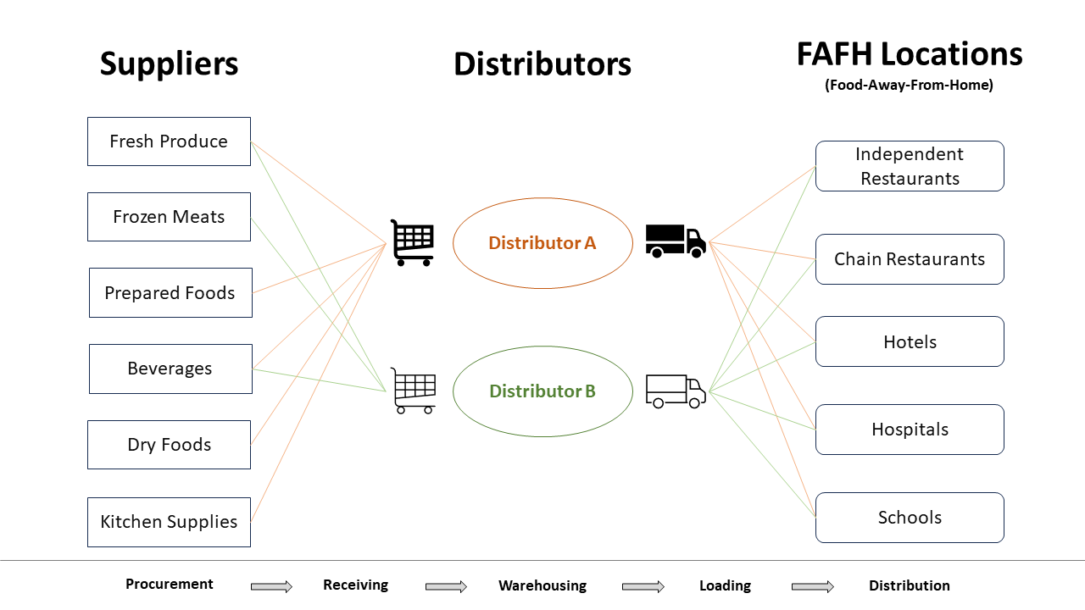

## Top Companies by Market Cap

According to Yahoo! Finance, as of the date of this analysis, Sysco Corporation (Sysco) is the largest foodservice distribution company in the U.S., followed by US Foods Holding Corp. (US Foods) and Performance Food Group Company (PFG). This analysis focuses on these three companies.

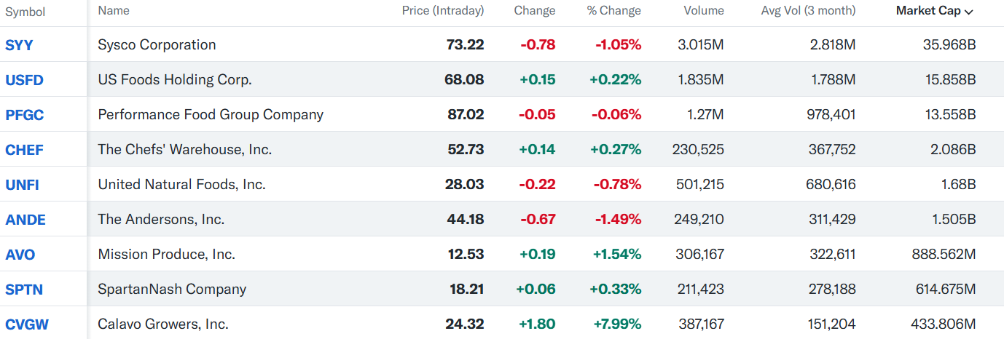

## Industry Trend

* Given their purchasing power and diverse taste profiles, **Millennials, Generation Z and Baby Boomers** will continue to significantly influence food consumption and the food-away-from-home market. When it comes to food, Millennials and Generation Z are open-minded and curious, and willing to seek out new flavors, dining experiences and diverse menu offerings, while also demanding customization, convenience, and sustainable products. As Millennials’ and Generation Z’s disposable income increases, foodservice distribution companies believe this demographic will be key to driving growth in the broader U.S. food industry. They also expect that Baby Boomers will continue to shape the industry as they remain in the workplace longer, which is expected to prolong their contribution to food-away-from-home expenditures.
* The industry sees **significant continued growth being driven by the increased utilization of, and reliance on technology** by foodservice distributors, customers, and diners. Digital solutions streamline the purchasing process and increase customer retention. They also deepen the relationship between foodservice distributors and customers, creating personalized insights and services that can make both more efficient. Companies in the industry believe foodservice distributors that have deeper, technology-enabled relationships with customers are better able to accelerate their customers’ adoption of new products and increase customer loyalty, giving them a competitive edge. They also believe these technology trends will continue to accelerate as Millennials and Generation Z place a greater reliance on technology and become key influencers and decision-makers within the food industry, including at the customer level. As a result, foodservice distribution companies focusing on strengthening their technology, data analytics, and related capabilities are expected to be well-positioned to capitalize on these trends.

## Common Risk Factors

* The foodservice industry is characterized by **relatively high inventory turnover with relatively low profit margins**. Periods of significant or prolonged inflation or deflation affect product costs and may negatively impact profitability and results of operations.
* The foodservice companies may not be able to fully compensate for **increases in fuel costs** which could adversely affect results of operations.
  + The cost of fuel affects the prices companies pay for products, as well as the costs theyincur to deliver products to customers. Companies require significant quantities of fuel for delivery and are exposed to the risk associated with fluctuations in the market price for fuel.
* Foodservice distributors often **obtain substantially most or all of their foodservice and related products from third-party suppliers**. Suppliers may not be able to provide the foodservice products and supplies that needed due to conditions outside of their control, which could adversely affect results of operations.
* Failure to successfully renegotiate **union** contracts could result in work stoppages, which could have a material adverse effect on the company’s business, financial condition and results of operations.

# Financial Ratio Industry Comparison (2023/2024)

Note:

* A more detailed analysis of each company will be provided in the next section.
* The formula for each ratio is described in the supplemental data section.
* Conditional formatting is applied by row.
* Sysco’s and PFG’s fiscal years end on the Saturday nearest to **June 30th**.
* US Foods’ fiscal year ends on a Saturday (in **Dec** or **Jan**).

## Profitability

### 2024



### 2023



Quick Insights:

* The industry has low profitability.
* Sysco shows the highest profitability among the three companies, while PFG has the lowest.

## Liquidity

### 2024



### 2023



Quick Insights:

* The industry has low liquidity, which is logical because companies in the foodservice distribution industry operate with high inventory turnover rates. They deal with perishable goods that require fast turnover to prevent spoilage. Instead of holding large cash reserves, they reinvest funds into inventory to meet demand promptly and take advantage of bulk purchasing discounts.

## Solvency

### 2024



### 2023



Quick Insights:

* Sysco is significantly more financially leveraged than the other two companies.

## Activity

### 2024



### 2023



Quick Insights:

* PFG has the longest cash conversion cycle, indicating that its cash is tied up longer in the operating cycle.
* Sysco’s DPO is longer than the other two, suggesting that the company has more favorable payment terms with suppliers, likely due to its strong bargaining power.

## Valuation

### 2024



### 2023



Quick Insights:

* Sysco pays dividends to its shareholders.

## Key Highlights

* All three companies have low profitability, but Sysco is the most profitable among them, while PFG is the least profitable.
* All three companies have low cash balances, likely because they reinvest cash into inventory.
* US Foods and PFG appear to have a similar capital structure, whereas Sysco is significantly more financially leveraged.
* Sysco pays dividends, while the other two don’t.

# Key Players Horizontal Analysis

## Sysco Corporation

### Employees & Labor Relations

As of June 29, 2024, the company employed approximately 76,000 employees, including 51,000 U.S. employees and 25,000 employees outside the U.S. Approximately 99% of its U.S.-based colleagues are classified as full-time, defined as employees who work 30 or more hours per week.

Approximately 15% of its employees were represented by unions, primarily the International Brotherhood of Teamsters and unions in France and Sweden. Approximately 9% of its union U.S. employees and 21% of its union international employees are covered by collective bargaining agreements that are subject to renegotiation in fiscal 2025.

### Business

Sysco distributes food and related products to restaurants, healthcare and educational facilities, lodging establishments and other foodservice customers. The company’s primary operations are in North America and Europe.

The company has four reportable segments: **U.S. Foodservice Operations**, **International Foodservice Operations**, **SYGMA** (U.S. customized distribution operations serving quick-service chain restaurants), and **Other** (primarily hotel supply operations)

Property

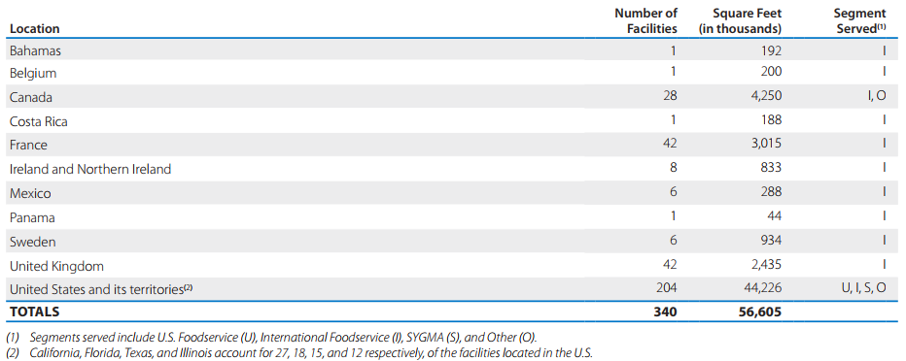

### Stock Performance Graph

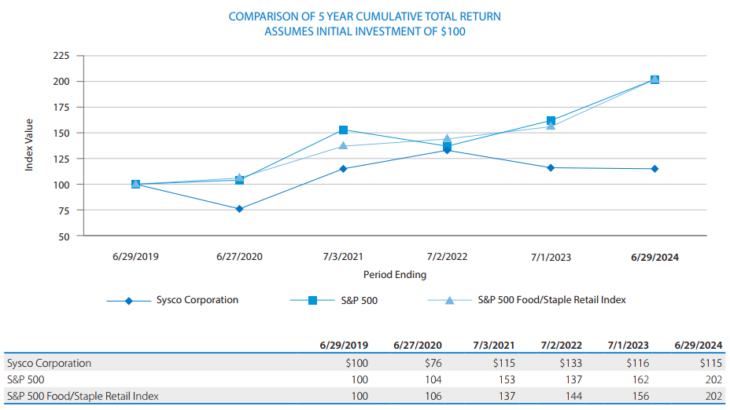

### KPIs

* Adjusted Operating Income Growth (operating efficiency and profitability)
* Adjusted Diluted Earnings Per Share (operating efficiency and profitability)
* Adjusted EBITDA (overall financial performance about the profitability)
* Case Volume Growth for U.S./Int. Foodservice Operations (sales and gross margin performance)
* Sysco Brand Penetration for U.S. Broadline Operations (gross profit performance)
* Free Cash Flow (liquidity)

### Balance Sheet Chart

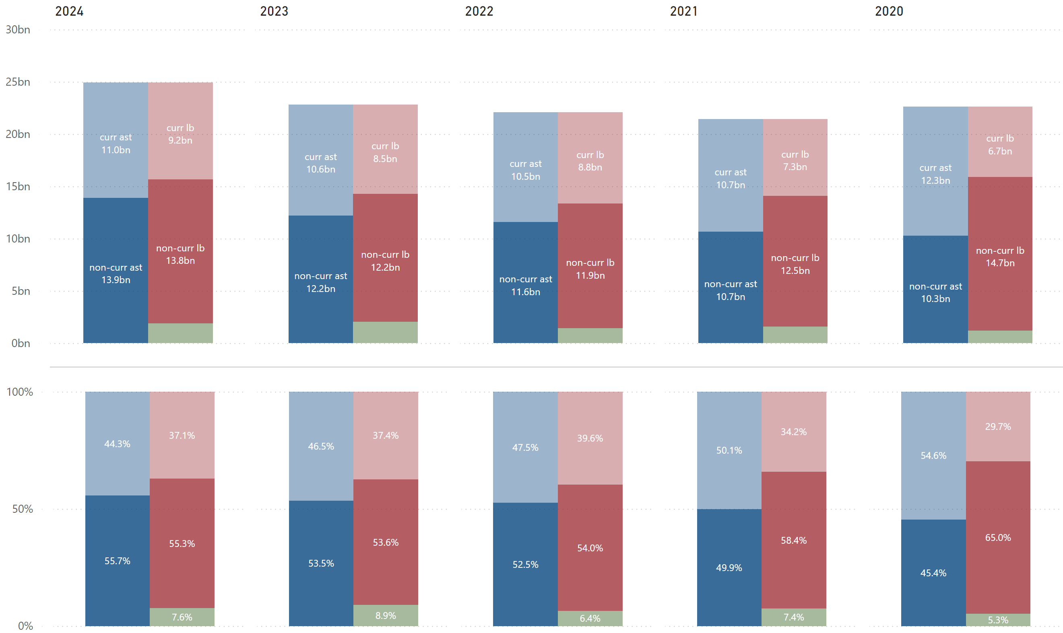

### P/L Chart

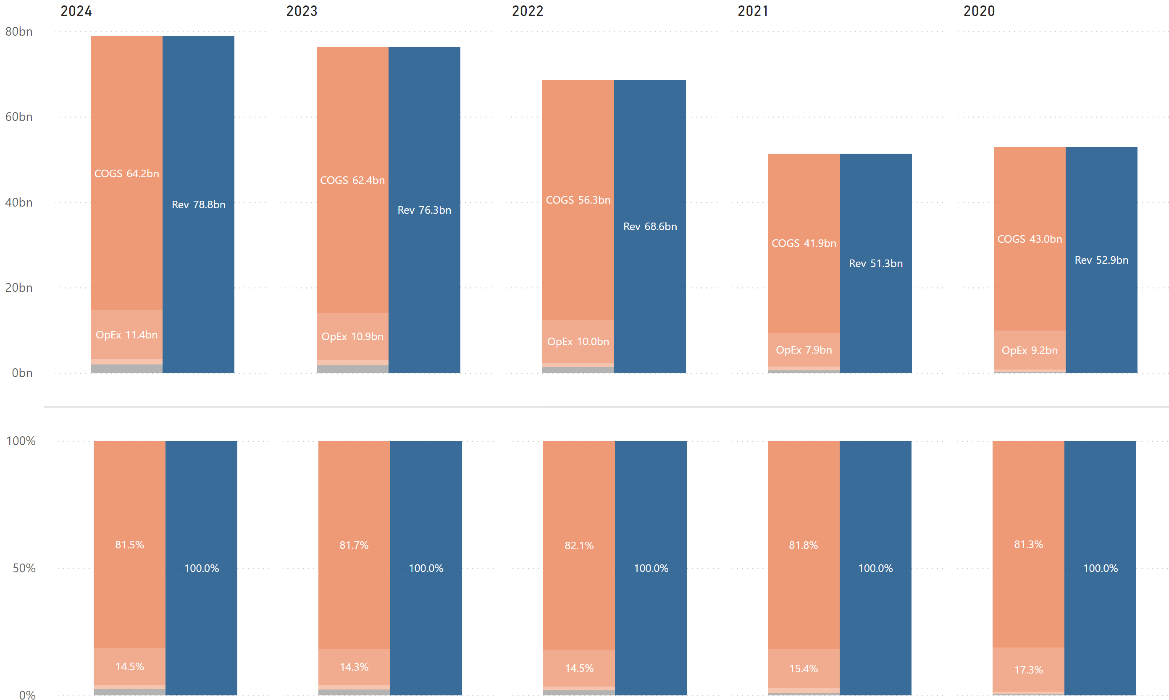

### Cash Flow Chart

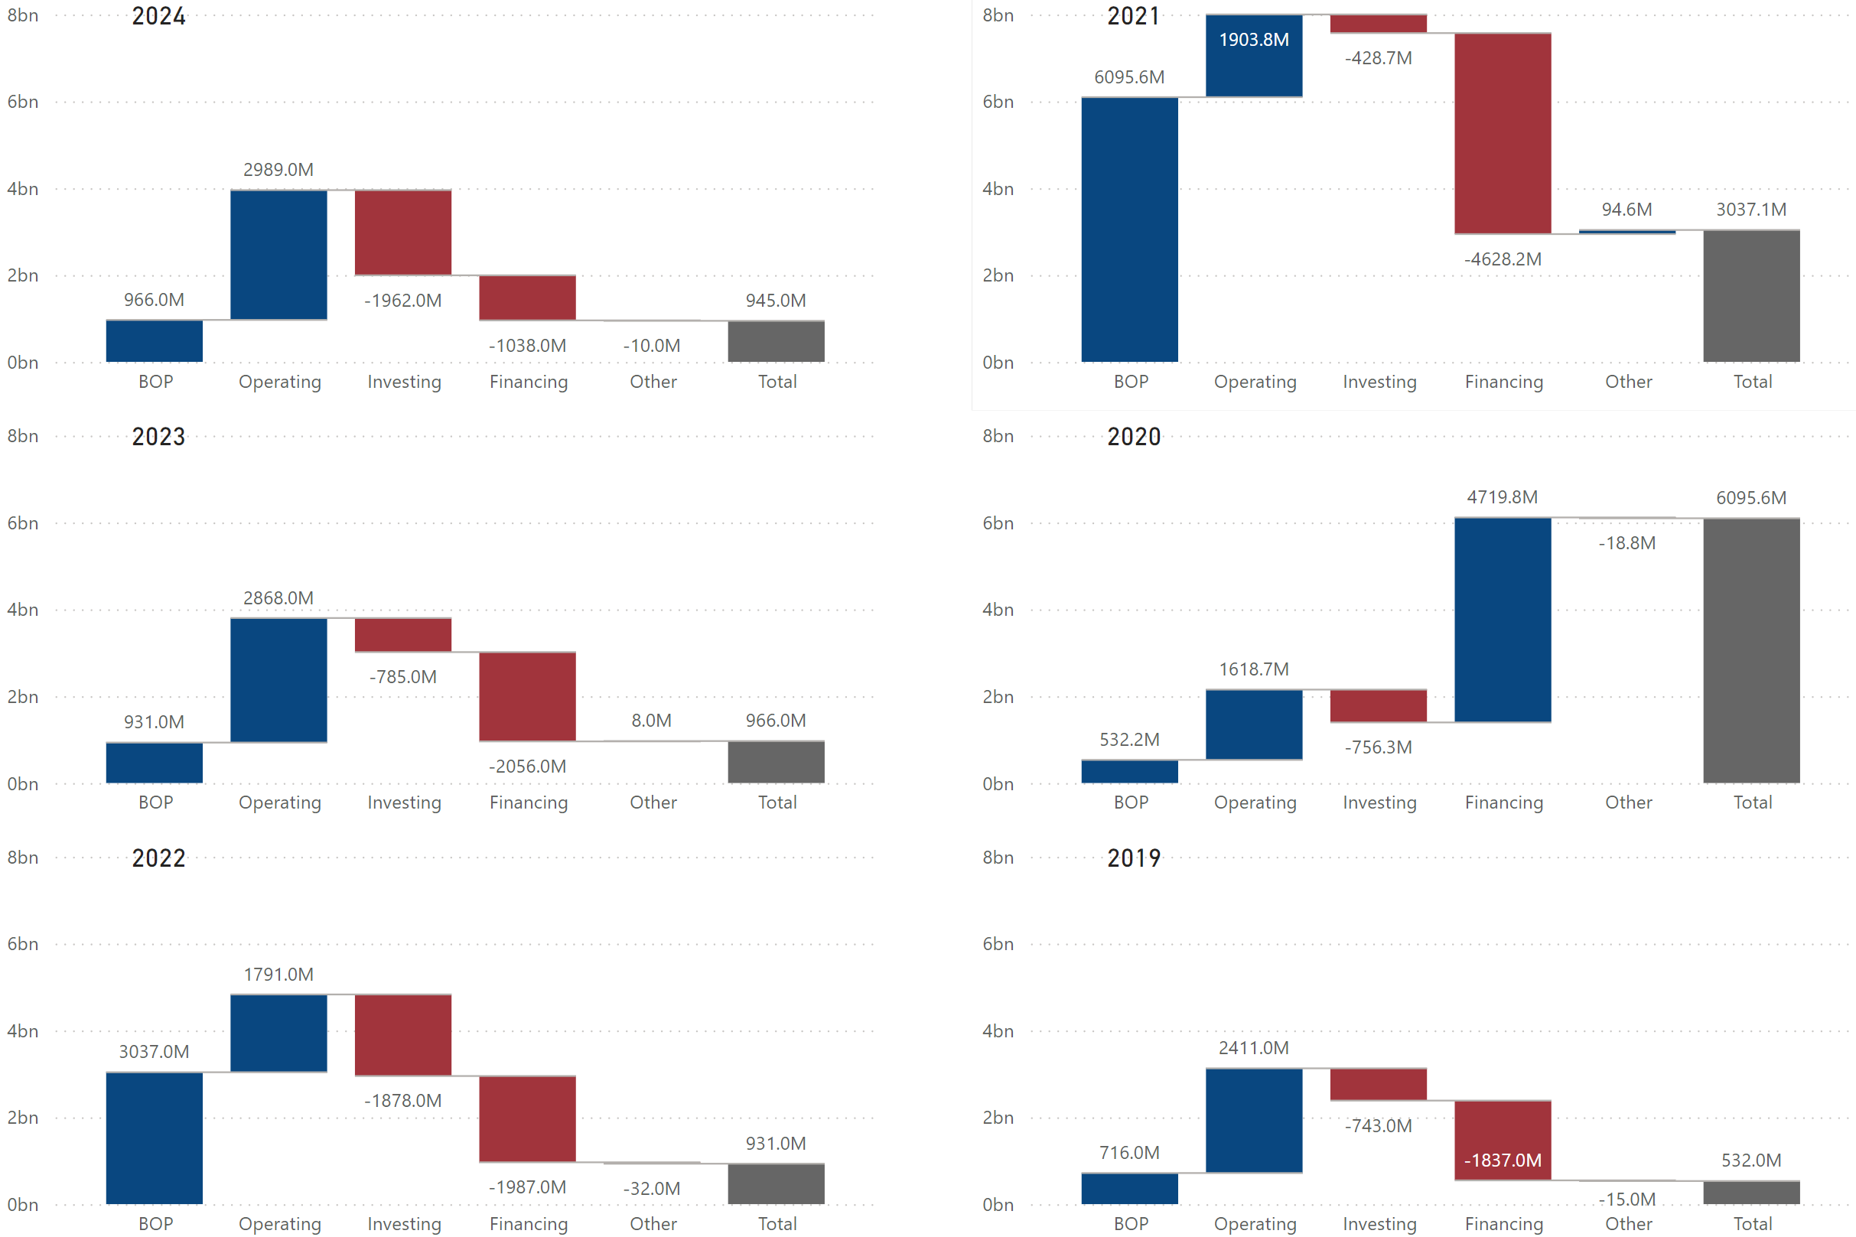

### Historical Financial Ratios



### Long-Term Debt (Most Recent Years)

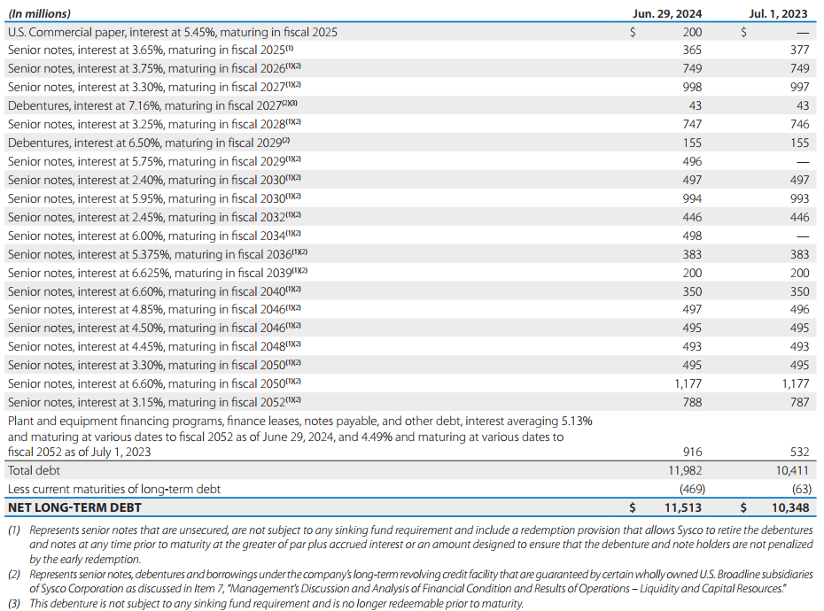

### Maturities of Long-Term Debt / Estimated Debt Service Requirements

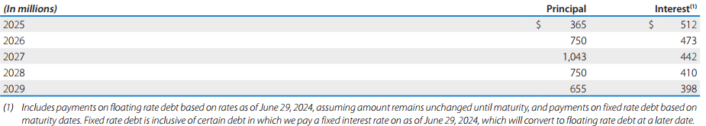

### Key Financial Insights

* (BL) ***The company’s total asset structure consists of approximately 50% current assets and 50% non-current assets.***
  + The company’s current assets primarily include accounts receivable (AR) and inventories*¹*.
    - According to the company’s annual report, its AR consists mainly of trade receivables from customers and receivables from suppliers for marketing or incentive programs.
    - The company’s inventories, primarily finished goods, include food and related products as well as lodging products held for resale.
  + The company’s non-current assets mainly consist of PP&E and goodwill*¹*.
    - The company’s goodwill has been increasing consistently for the past 5 years*¹*. This trend indicates the company has been actively acquiring other businesses or assets. Recent acquisitions include Greco and Sons, a leading independent Italian specialty distributor in the U.S., in 2022, and Edward Don & Company, a leading distributor of foodservice equipment, suppliers, and disposables, in 2024.
      * This is a common strategy among major industry players. There are various reasons for large companies like Sysco to acquire smaller companies, including but not limited to:
        + Increasing market share
        + Expanding into new geographic areas
        + Diversifying products and services
        + Acquiring talent
        + Eliminating competition
* (PL) ***The*** ***COGS % is significantly high, lowering the company’s overall profitability.***
  + According to the company’s annual report, its COGS primarily includes inventory costs and inbound freight.
  + The business model of foodservice distribution companies like Sysco revolves around acting as intermediaries between food producers/manufacturers and end customers.
    - Purchase food and related products in bulk from manufacturers, farmers, etc.
    - Store these products in their distribution centers.
    - Transport goods using their network of trucks to deliver products.
    - Offer value-added services to encourage loyalty and repeat business.

Since food and related products are often commodities, their business relies on selling high volumes of products with relatively low profit margins on each sale. This **cost-plus pricing model**, where they add a small markup to their costs, keeps gross margins tight.

* (PL) ***The company’s operating expenses account for about 15% of total revenues.***
  + The company’s operating expenses include the costs of facilities, product handling, delivery, SG&A activities. The company uses operating income as one of the main metrics for evaluating segment performance and allocating resources. This makes sense, as operating income accounts for the cost of goods sold, in addition to the costs to warehouse and deliver goods, which are significant and relevant costs when evaluating a distribution business. However, the company’s annual reports do not provide further details to perform deeper analysis.
* (PL/Ratio/Debt) ***While the company is financially leveraged, its interest burden is low.***
  + The company’s financial leverage is high (6-year average of 13.27) due to its larger liabilities (over 90%) than equity (less than 10%). Its largest liability is long-term debt, followed by accounts payable (AP)*¹*. However, the company’s reliance on debt is not as high as it appears since AP is not debt, as indicated by its debt-to-assets ratio of 0.52.
  + About 46.2% of total assets are financed by long-term debt*¹*. Its long-term debt mainly consists of longer-term senior notes with reasonable interest rates (2%-6%). This reduces the company’s annual commitment to interest payments.
    - Senior notes are often considered the most secure debt, carrying less risk compared to other types of debt.
* (CF) ***It appears that the company financed a significant amount of cash in 2020 but paid off most of it the following year.***
  + In the fiscal year of 2020, the company took steps to increase liquidity and reduce variable and structural costs in response to the COVID-19 pandemic. It increased liquidity by:
    - Borrowing $1.6 billion under its revolving credit facility
    - Offering $4 billion unsecured bond
    - Establishing a £600 million Bank of England commercial paper program, and
    - Issuing a new $750 million 364-day credit facility

As a result of these measures, the company generated positive cash flows of about $4.8 billion from financing activities in 2020, which were partially offset by debt repayments*²*.

* + In the fiscal year of 2021, the company did not fully pay off the debt incurred in 2020 but continued to reduce its debt levels, paying down over $3 billion of debt*²*.
  + The company has a significant amount of retained earnings, but this is offset by treasury stock recognized through share repurchase. The company’s annual report mentions plans to utilize treasury stock for share-based compensation. However, there are other possible reasons behind this:
    - Resale: the company believes that its stock price will increase.
    - Strategic Considerations: treasury stock can be used strategically to support or defend against corporate actions such as mergers, acquisitions, or hostile takeovers.
* (CF) ***It seems that the company has been targeting an EOP cash balance of around $950 million over the last few years.***
  + Over the past 2 years, the company has spent as much cash on investing and financing activities as it generated from operating activities, resulting in almost no change in its EOP balances. This is one of the healthiest cash flow patterns (+, -, -).
* (Ratio) ***The company has been spending over 50% of its net income to pay dividends.***
  + Sysco is one of the so-called **dividend aristocrats**: companies in the S&P 500 index that have increased their dividend payouts for at least 25 consecutive years. As its DPR shows, the company paid more in dividends than its net income during the COVID-19 period, resulting in a DPR of over 100%. This demonstrates the company’s commitment to returning value to shareholders through dividends.
  + A company that pays out an ever-increasing dividend is ideal for investors looking for stable income, and being such a company is a positive signal that the firm is on sound financial footing. However, a dividend is a portion of a company’s profits that it pays to its owners. Any money paid out as a dividend is not reinvested in the business.
* (Debt) ***It seems that the company’s future debt maturities are not significant over the next 5 years.***
  + The company’s historical free cash flow and working capital indicates that it has the ability to meet its future debt obligations*²*.

*¹ Refer to* ***Sysco’s historical balance sheet*** *in the supplemental data section.  
² Refer to* ***Sysco’s******historical cash flow statement*** *in the supplemental data section.*

## US Foods

### Employees & Labor Relations

As of December 30, 2023, the company employed a total of approximately 30,000 associates. Of these:

* substantially all were employed in the United States and on a full-time basis;
* approximately 69% of the company’s associates were non-exempt, or paid on an hourly basis;
* approximately 6,300 of the company’s associates were members of local unions associated with the International Brotherhood of Teamsters and other labor organizations; and
* approximately 86% of the company’s associates were working in “field” based roles within its broadline distribution, retail operations and broadline support business production facilities, with the remaining 14% working in shared service or corporate roles.

### Business

The company supplies approximately 250,000 customer locations nationwide. These customer locations include independent restaurants, chain restaurants, healthcare, hospitality, education, and other customers.

The company provides fresh, frozen, and dry food products, as well as nonfood items, sourced from thousands of suppliers. Its extensive network of over 70 distribution facilities and fleet of over 6,500 trucks, along with approximately 90 cash and carry locations, allows the company to operate efficiently and provide high levels of customer service.

### Property

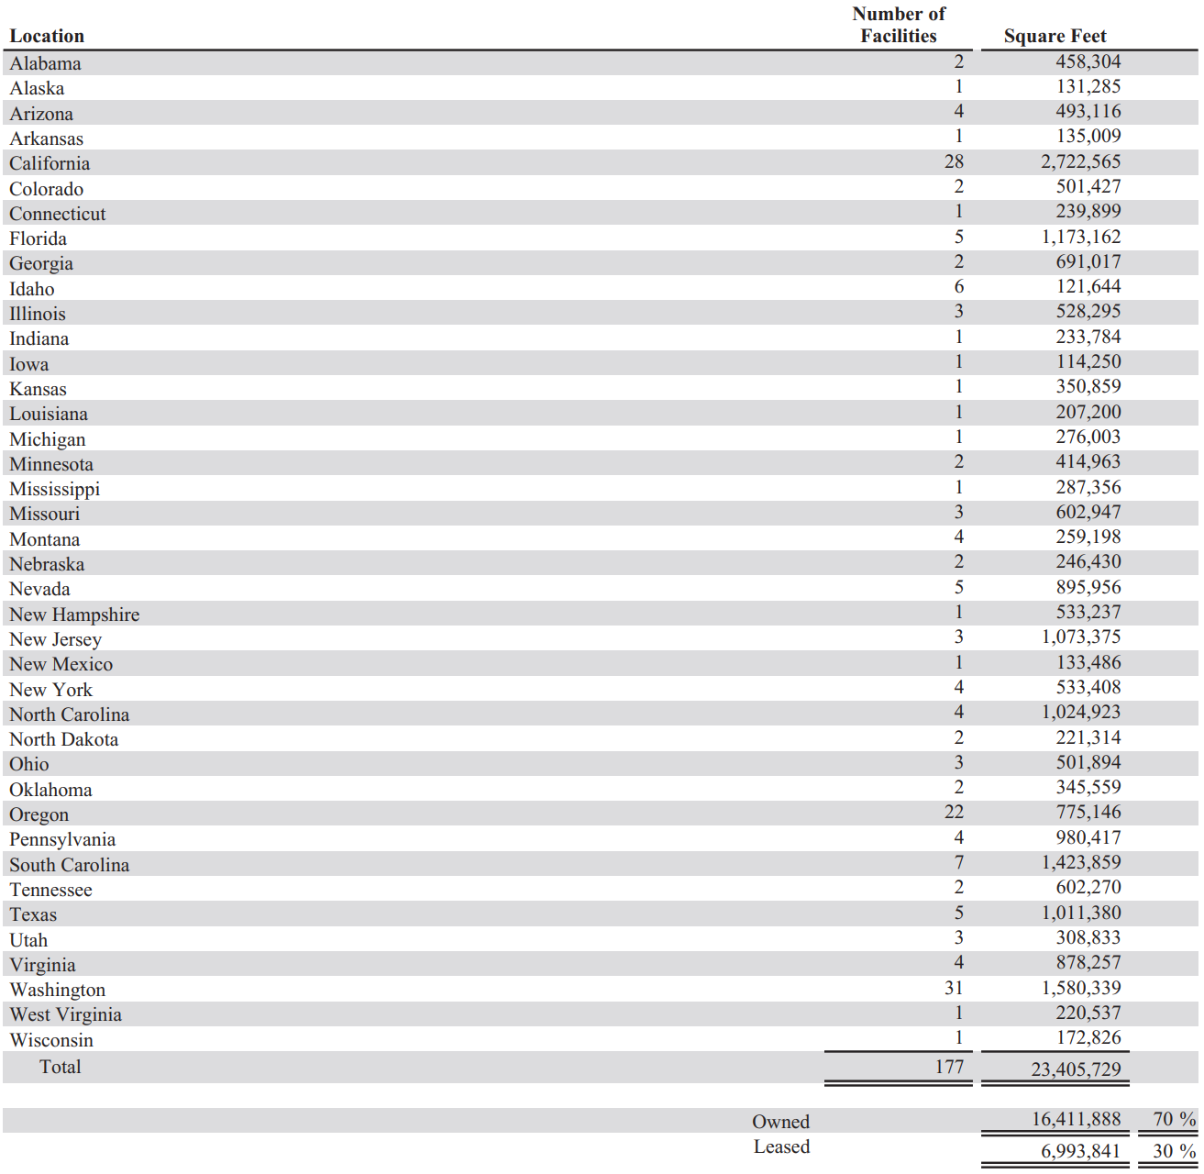

### Stock Performance Graph

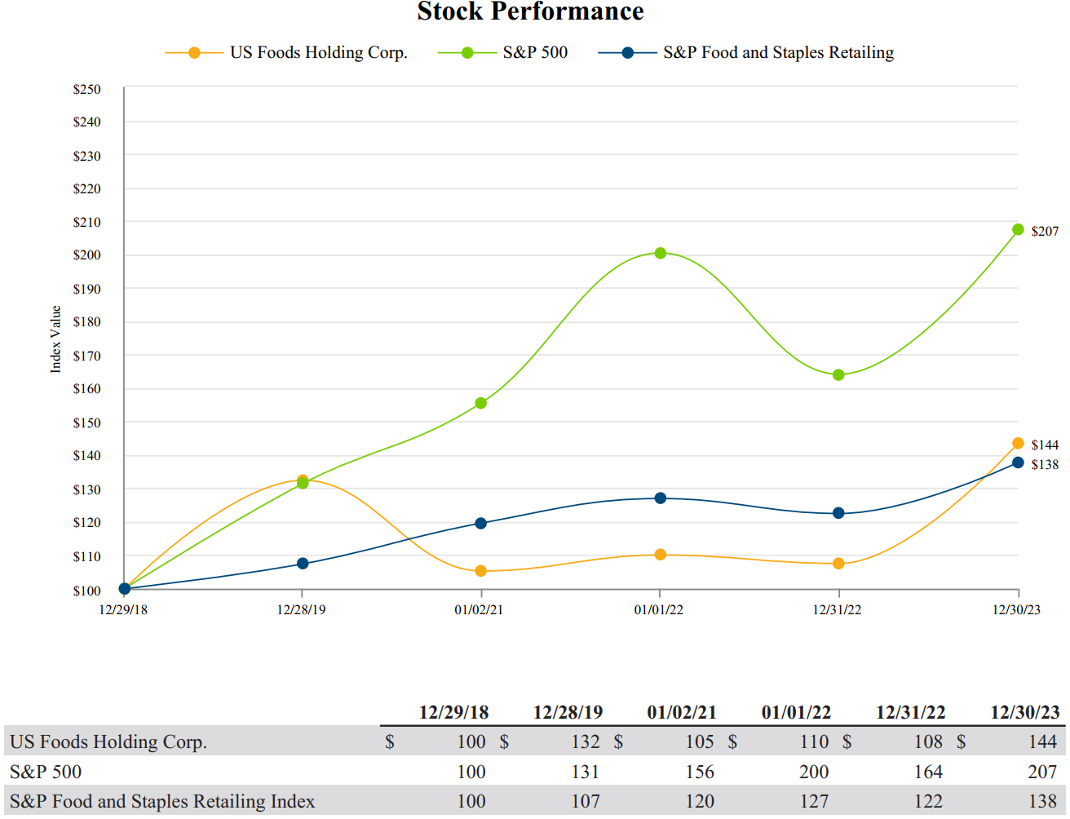

### KPIs

* Case Growth
* Operating Businesses Growth

### Balance Sheet Chart

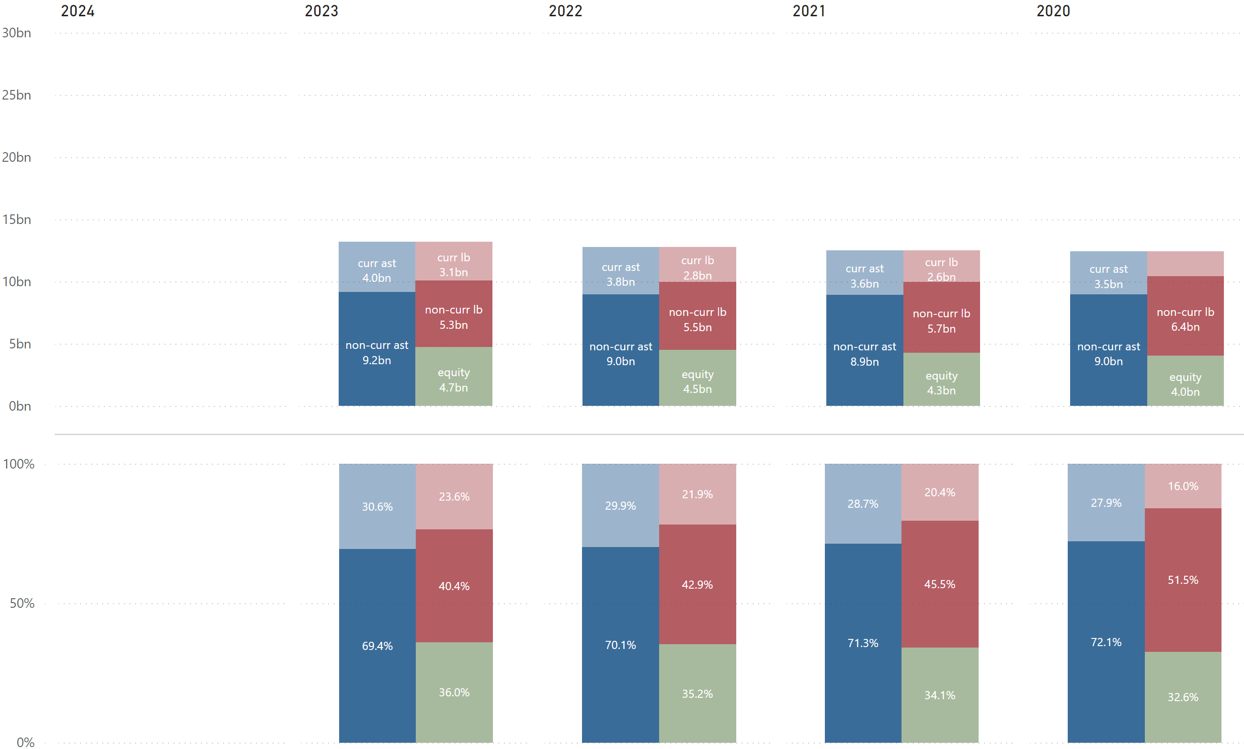

### P/L Chart

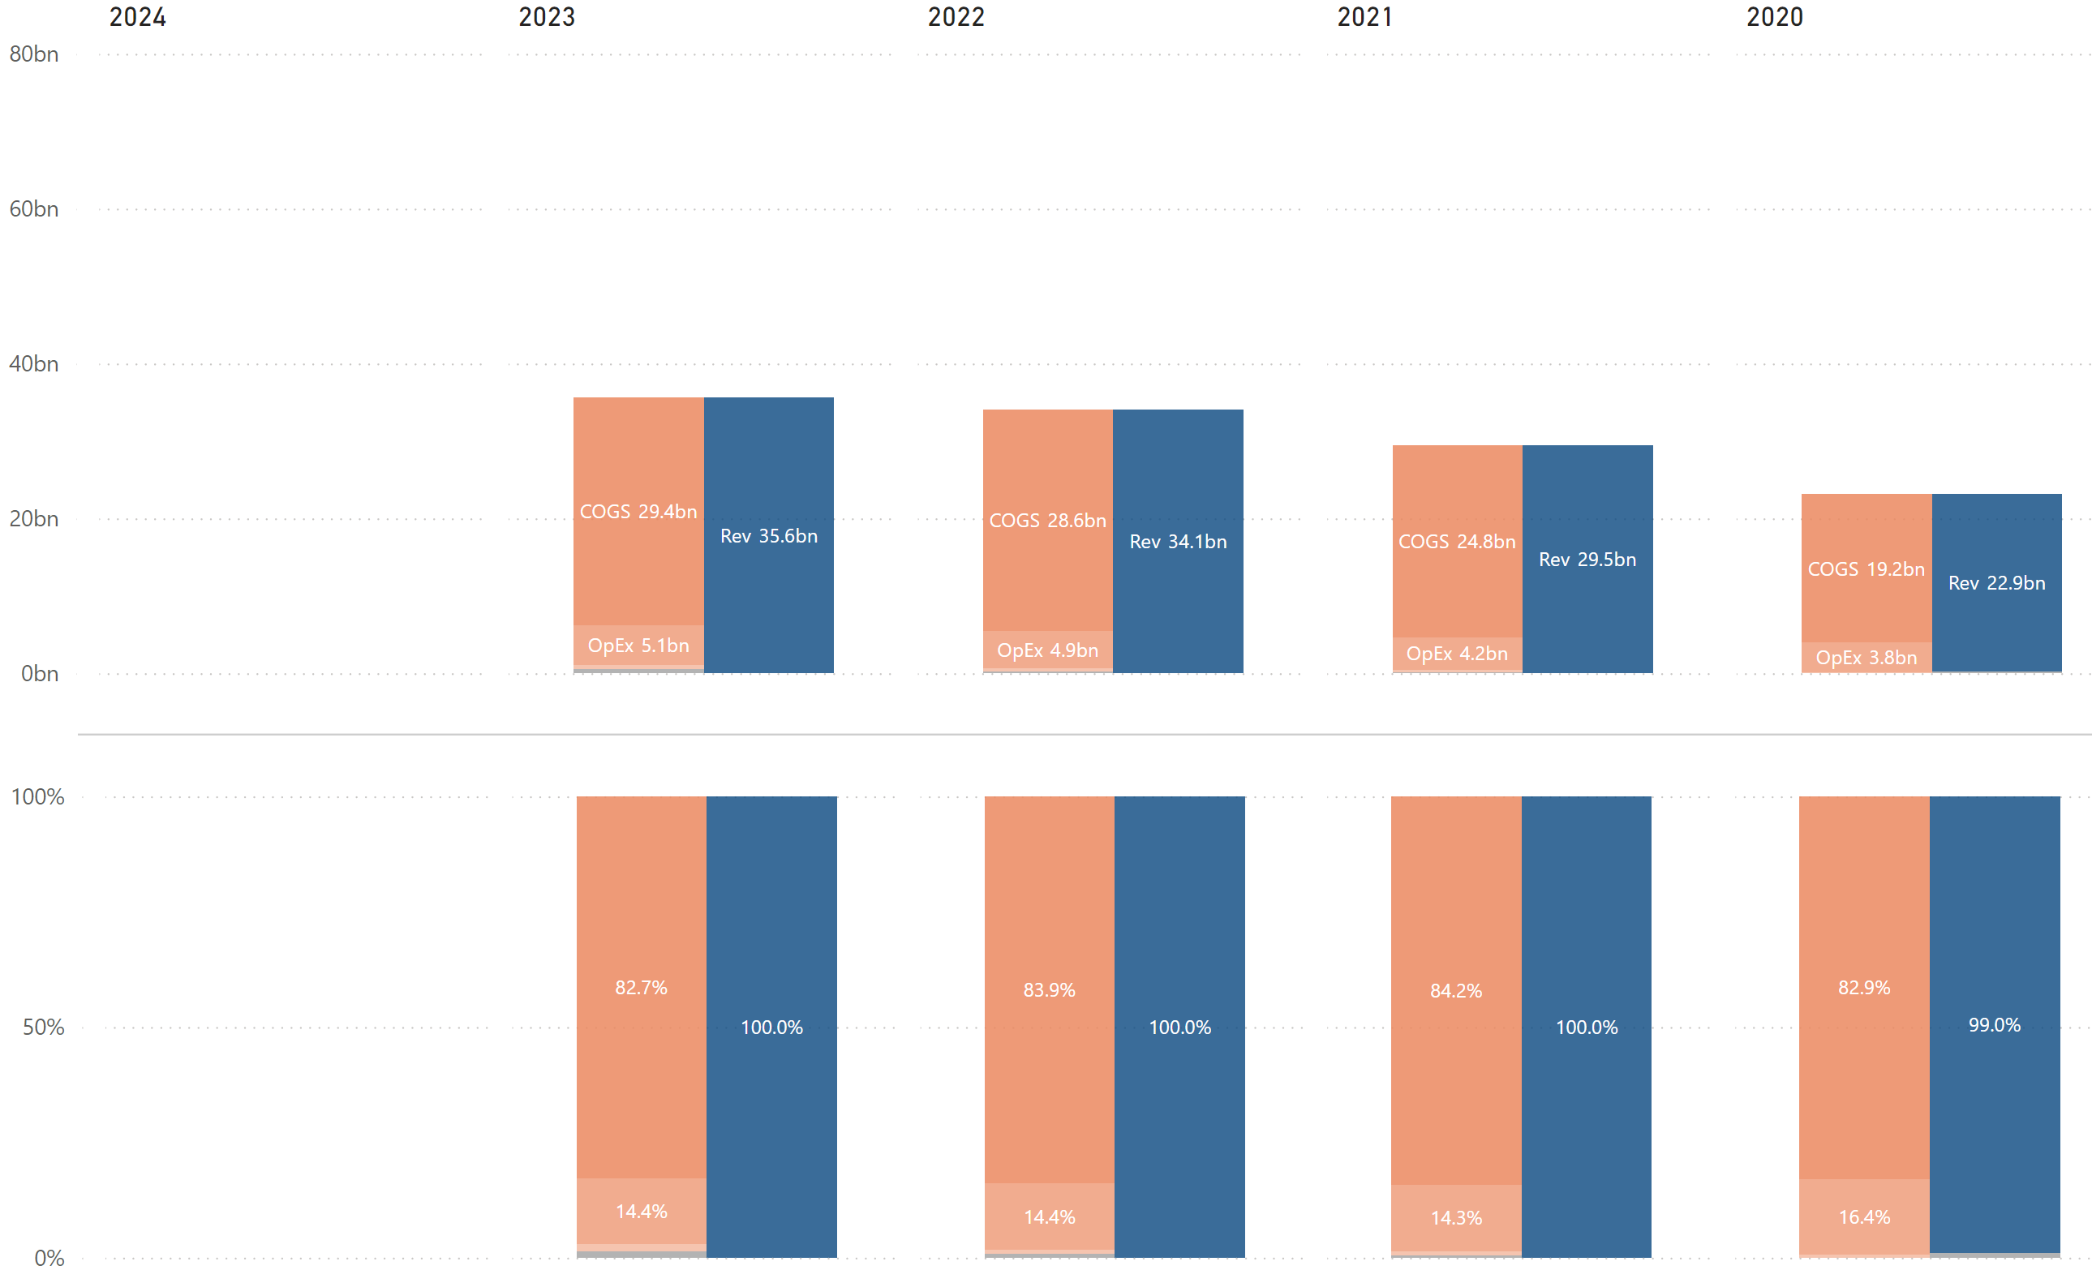

### Cash Flow Chart

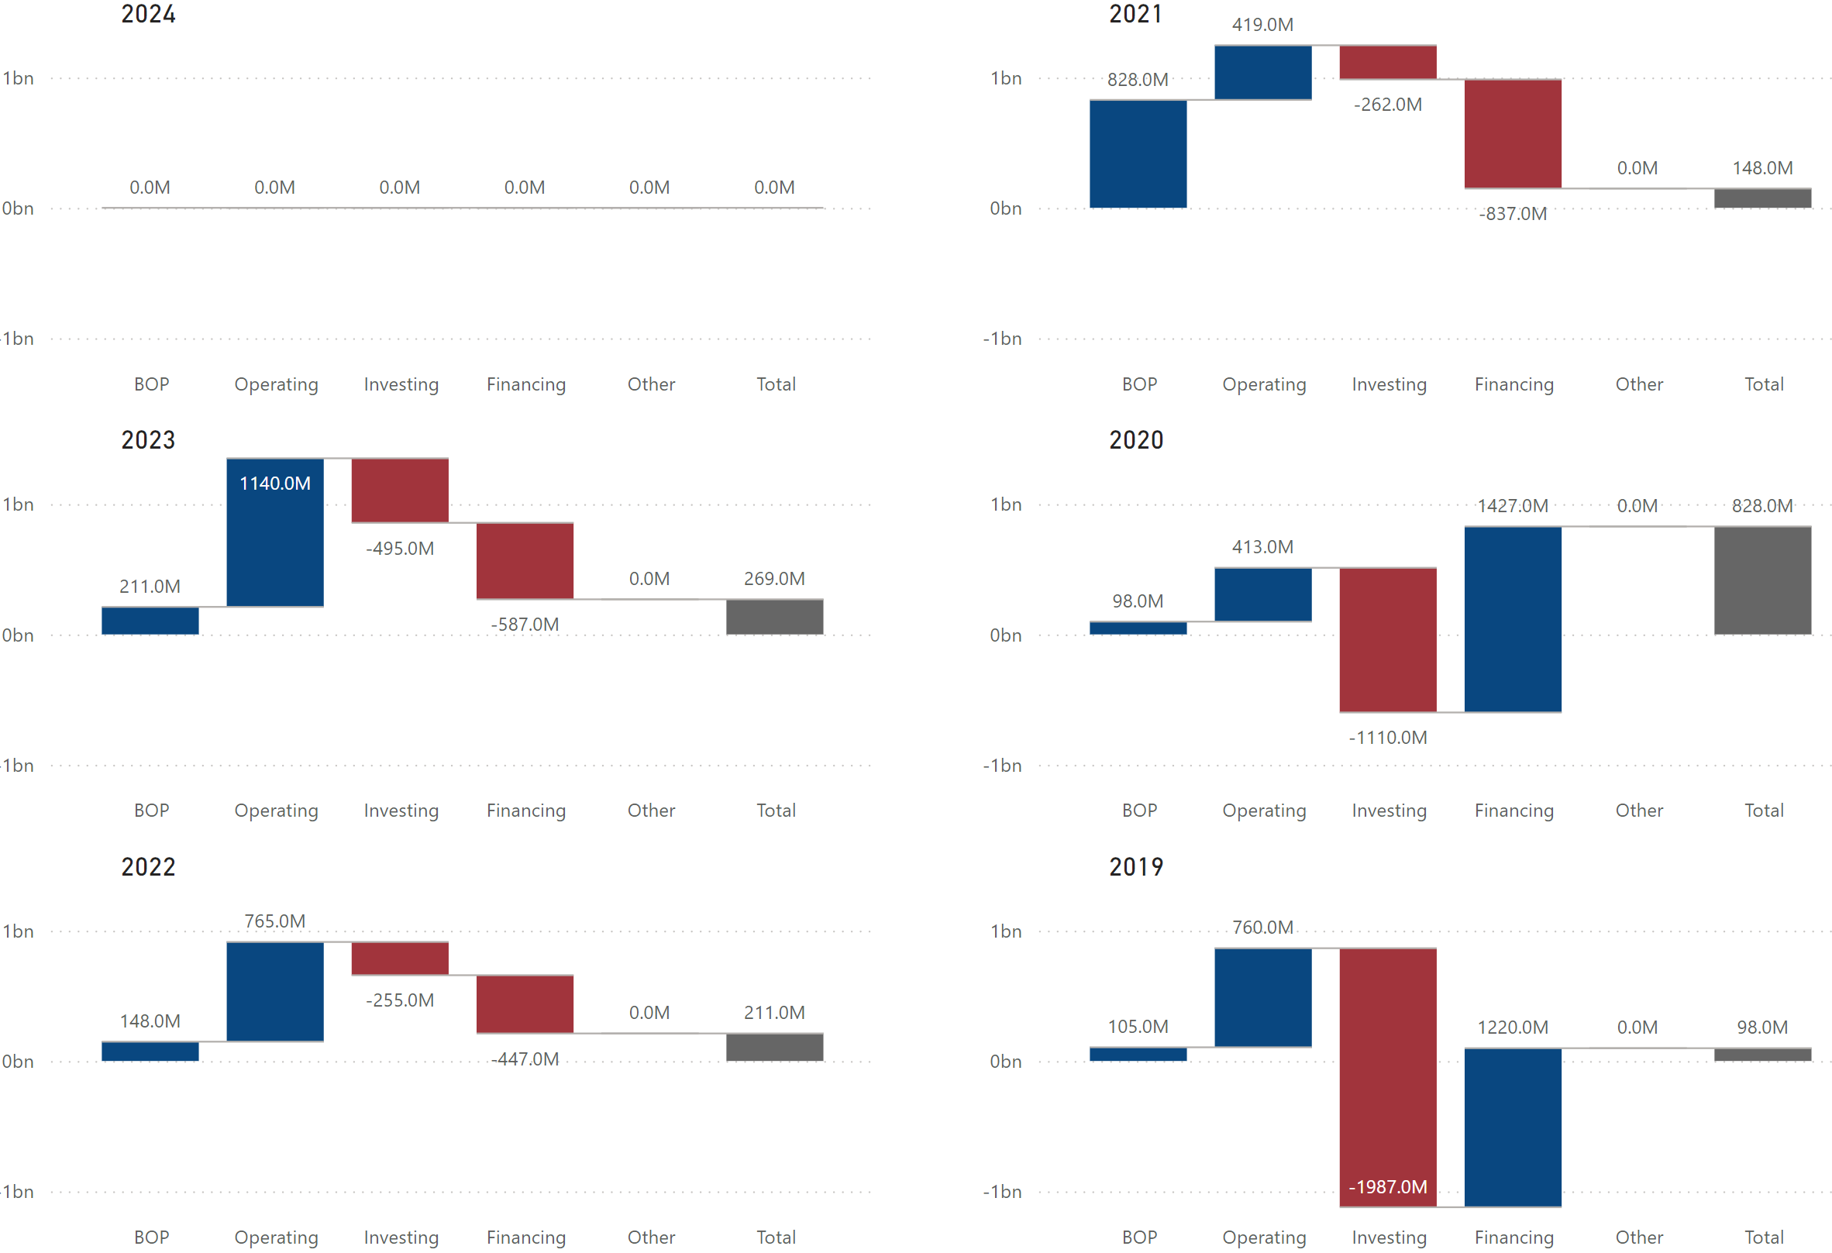

### Cash Flow Chart – Relative to Sysco

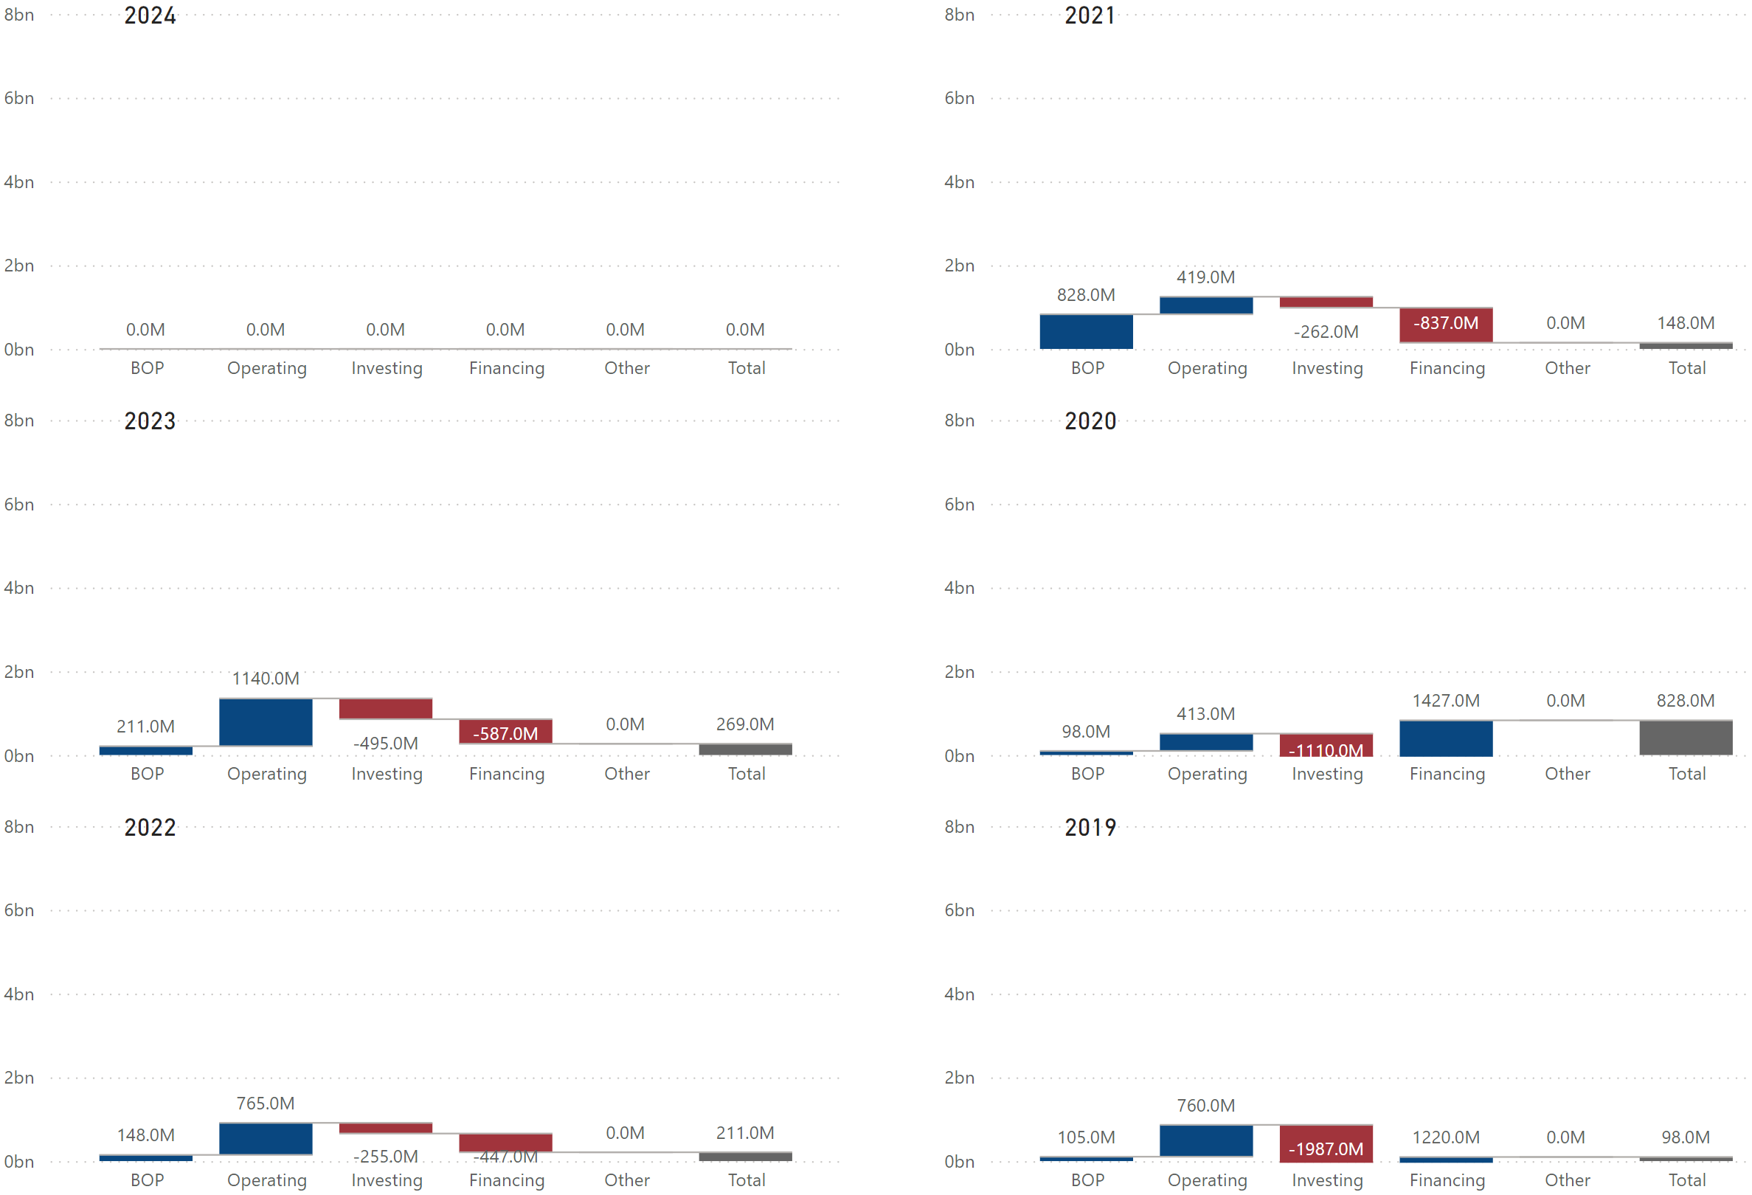

### Historical Financial Ratios



### Long-Term Debt (Most Recent Years)

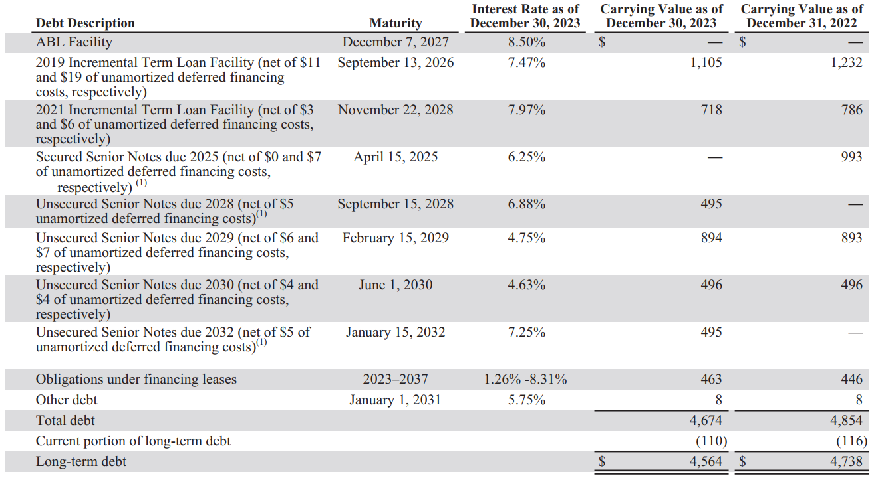

### Maturities of Long-Term Debt / Estimated Debt Service Requirements

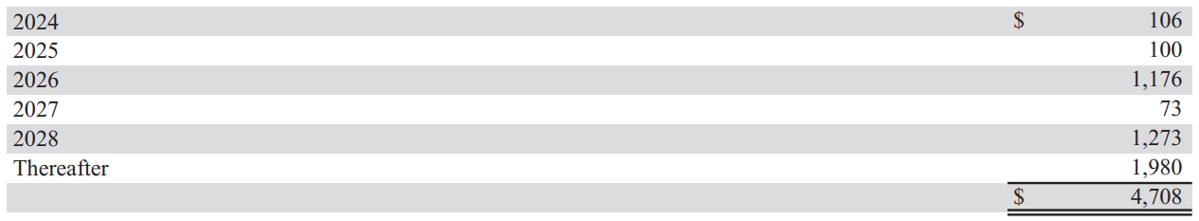

### Key Financial Insights

* (BL) ***The company’s non-current assets % is about 15%-20% higher than Sysco’s.***
  + The company’s asset structure is similar to Sysco’s: current assets mainly consist of accounts receivable and inventories, while non-current assets primarily consist of PP&E and goodwill*¹*.
  + The company’s higher non-current assets % is primarily due to its goodwill, which accounts for 43.2% of total assets*¹*, while Sysco’s goodwill accounts for 20.7% of total assets.
    - This indicates the company is more reliant on M&A as a growth strategy and more willing to pay premiums above fair value, reflecting eighter a competitive market for targets or strategic imperatives to expand rapidly.
    - Most recently, the company acquired Renzi Foodservice and Saladino’s Foodservice in 2023 to further expand its reach into New York and California, respectively.
* (BS) ***The company’s equity % is significantly higher than Sysco’s.***
  + Both Sysco’s and US Foods’ equity mainly consist of retained earnings and additional paid-in capital*¹*.
  + Sysco’s retained earnings are much larger than its additional paid-in capital, which reflects strong historical profitability. However, the retained earnings are offset by the large treasury stock balance, reducing equity significantly. This results in higher financial leverage.
  + On the other hand, US Foods’ retained earnings are smaller than its additional paid-in capital*¹*. This reflects significant equity financing through issuing shares, potentially during IPOs or capital raises, and its shorter operational history as a public company. Since US Foods does not hold as much treasury stock as Sysco, the company’s equity % is much higher.
* (PL) ***The company’s COGS % is slightly higher than Sysco’s, resulting in lower net income margin.***
  + There are several possible reasons behind this:
    - US Foods might have less pricing power than Sysco.
    - Sysco might have better economies of scale, operational efficiencies, etc.
    - Sysco might have a greater proportion of higher-margin products.
* (CF) ***The company spent significantly on investing activities in 2019 and 2020***.
  + The company’s large negative cash flows from investing activities in 2019 and 2020 were primarily due to business acquisitions*²*.
    - In 2019, the company completed the acquisition of five foodservice companies from Service Group of America, Inc. The acquisition expanded its network in the West and Northwest regions of the U.S.
    - In 2020, the company completed the acquisition of Smart Stores Holding Corp., further expanding its cash and carry business in the West and Northwest regions of the U.S.
* (CF) ***It appears that the company raised cash through financing activities in response to the COVID-19 pandemic in 2020 and paid off a large portion of these debts in the following year***.
  + According to its annual report, the company’s large cash inflows from financing activities in 2020 were primarily due to proceeds from debt borrowings, partially offset by principal payments on debt and financing leases*²*.
  + The company mentions that the proceeds from these borrowings were used to finance the Smart Foodservice acquisition and preserve financial flexibility, considering the business uncertainty resulting from the COVID-19 pandemic. It also states that the entire outstanding balance borrowed in response to the pandemic was repaid by January 2nd, 2021.
* (CF) ***The company has been spending as much cash on investing and financing activities as it generated from operating activities over the last 2 years.***
  + The company’s positive cash flows from investing activities in 2022 and 2023 were mainly due to capital expenditures, while its negative cash flows from financing activities were primarily due to debt repayments in both years.

* (Debt) ***It appears that the company has higher interest rates with shorter maturity periods compared to Sysco***.
  + There are several possible reasons for this:
    - The market perceives US Foods as having slightly higher credit risk compared to Sysco.
    - US Foods may have less favorable terms due to smaller scale or lower market dominance relative to Sysco.

*¹ Refer to* ***US Foods’******historical balance sheet*** *in the supplemental data section.  
² Refer to* ***US Foods’ historical cash flow statement*** *in the supplemental data section.*

## Performance Food Group (PFG)

### Employees & Labor Relations

As of June 29, 2024, the company’s associate population (including consolidated subsidiaries) totaled approximately 37,000 full-time and part-time associates in North America. Of that total, approximately 99% were employed on a fulltime basis, and approximately 70% were non-exempt, or paid on an hourly basis.

Approximately 2,245 were members of local unions associated with the International Brotherhood of Teamsters or other unions.

### Business

Performance Food Group Company markets and distribute food and food-related products from 144 distribution centers to over 300,000 customer locations across North America. Its approximately 37,000 employees serve a diverse mix of customers, from independent and chain restaurants to schools, business and industry locations, hospitals, vending distributors, office coffee service distributors, retailers, convenience stores, and theaters.

The company sources its products from various suppliers. In addition to the products the company offers to its customers, it provides value-added services by allowing its customers to benefit from its industry knowledge, scale, and expertise in the areas of product selection and procurement, menu development, and operational strategy.

The company has three segments: Foodservice, Vistar, Convenience:

* Foodservice offers a “broad line” of products.
* Vistar is a leading national distributor of candy, snacks, beverages, and other items to vending and office coffee service distributors.
* Convenience is one of the largest foodservice and wholesaler consumer products distributors in the convenience retail industry, offering a full range of products, marketing programs and technology solutions.

### Key Risk Factors Unique to PFG

* A significant portion of the company’s sales volume is dependent upon the distribution of cigarettes and other tobacco products, sales of which are generally declining.

### Property

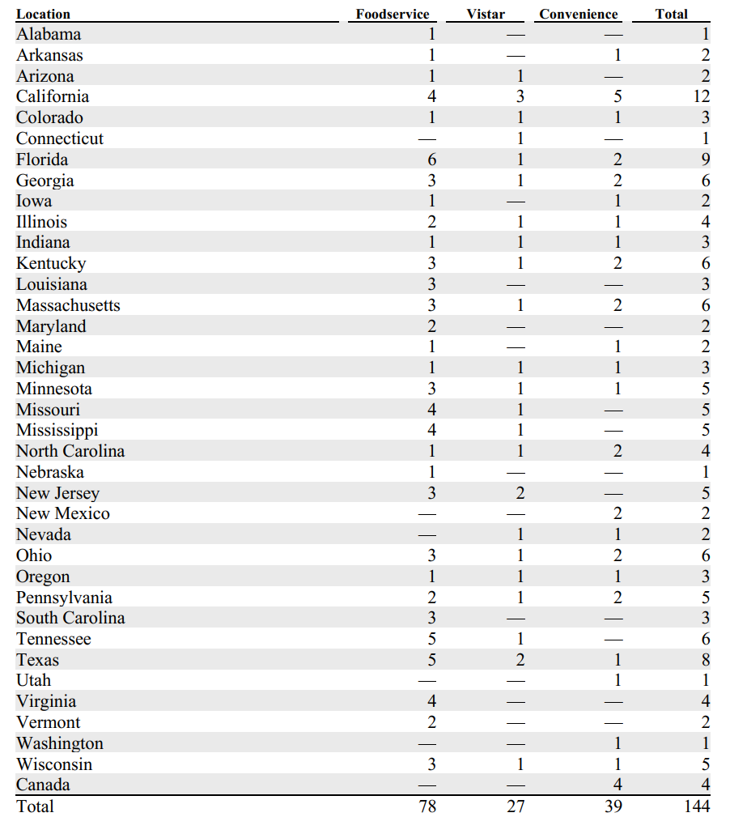

### Stock Performance Graph

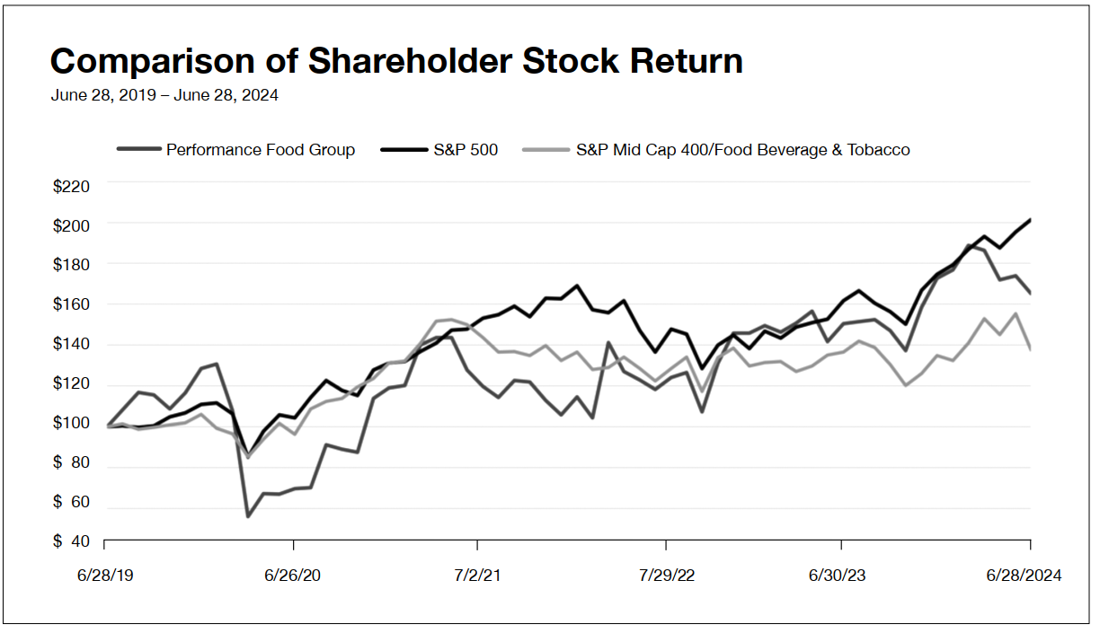

### KPIs

* Net Sales (changes in case volumes, product inflation, and mix of products sold)
* Gross Profit (changes in COGS, which primarily includes inventory and inbound freight)
* Adjusted EBITDA (operating performance)

### Balance Sheet Chart

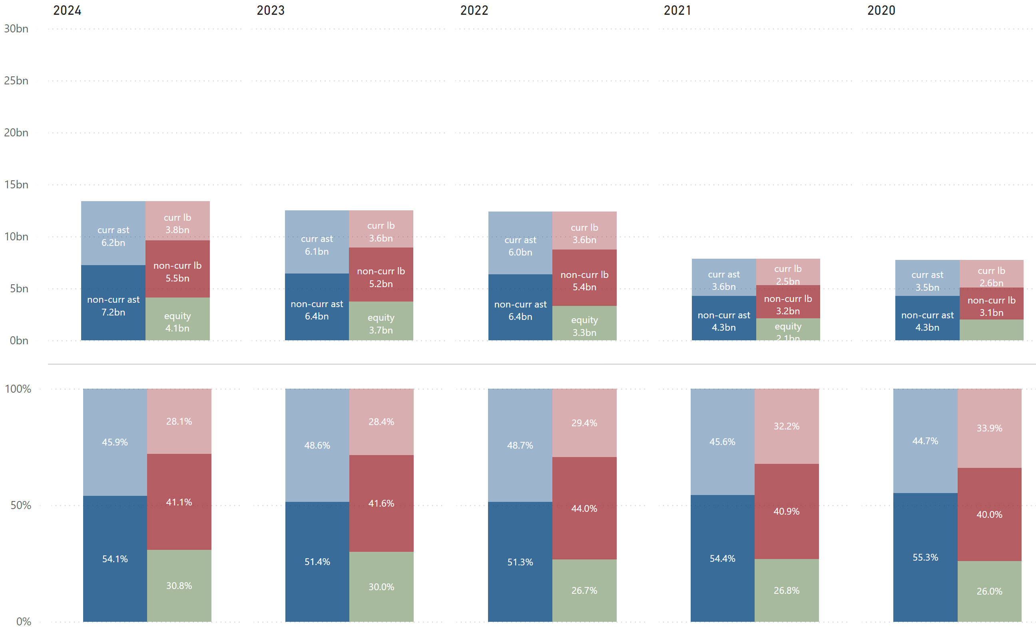

### P/L Chart

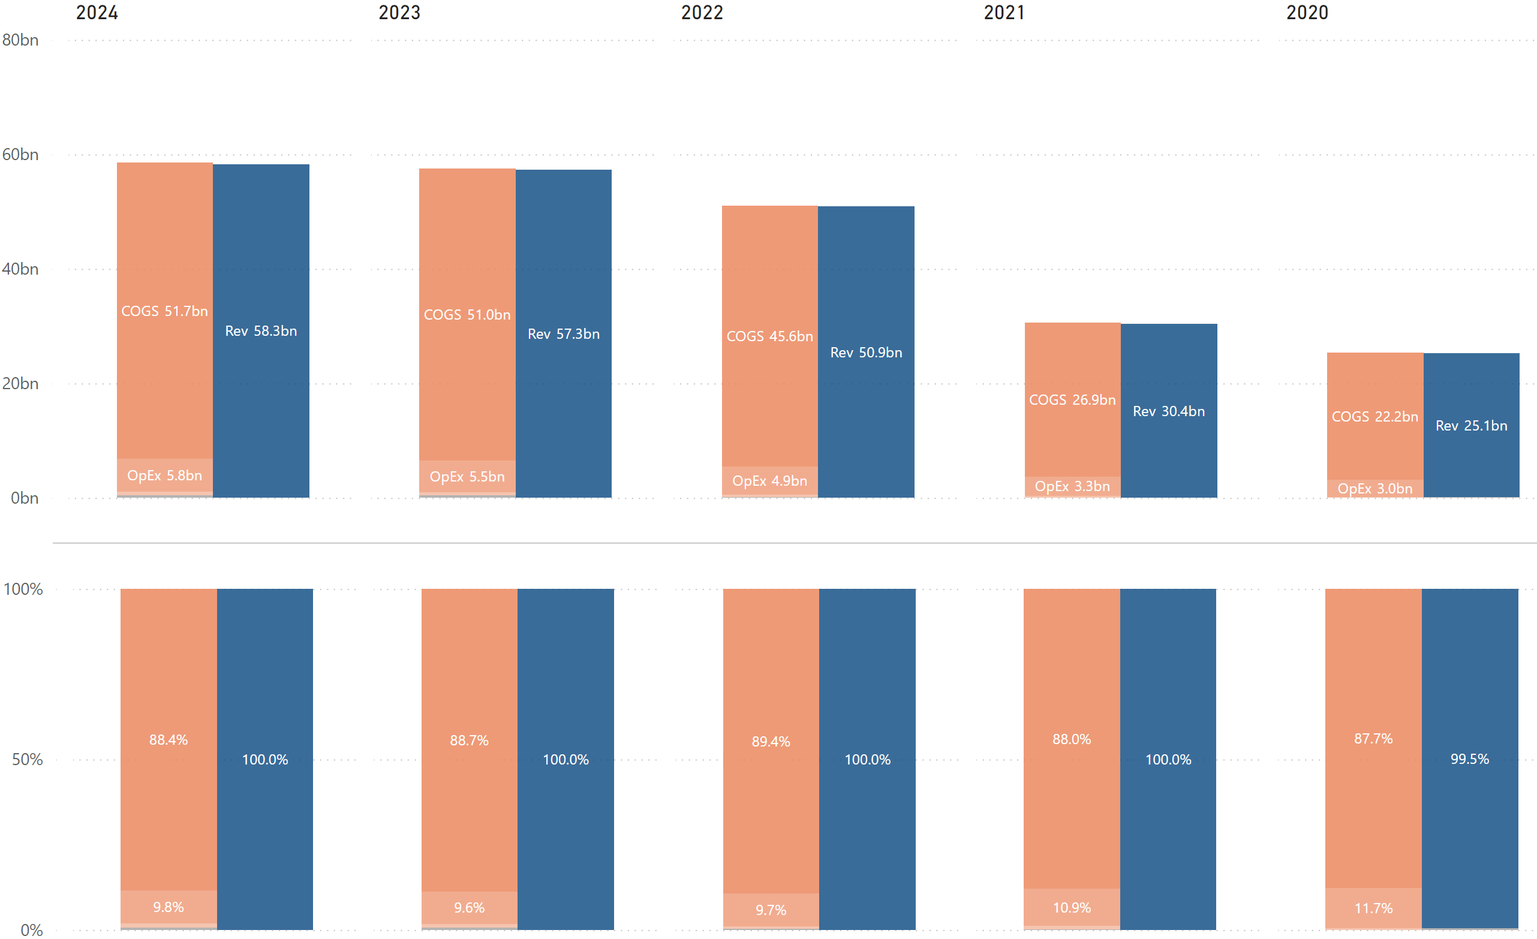

### Cash Flow Chart

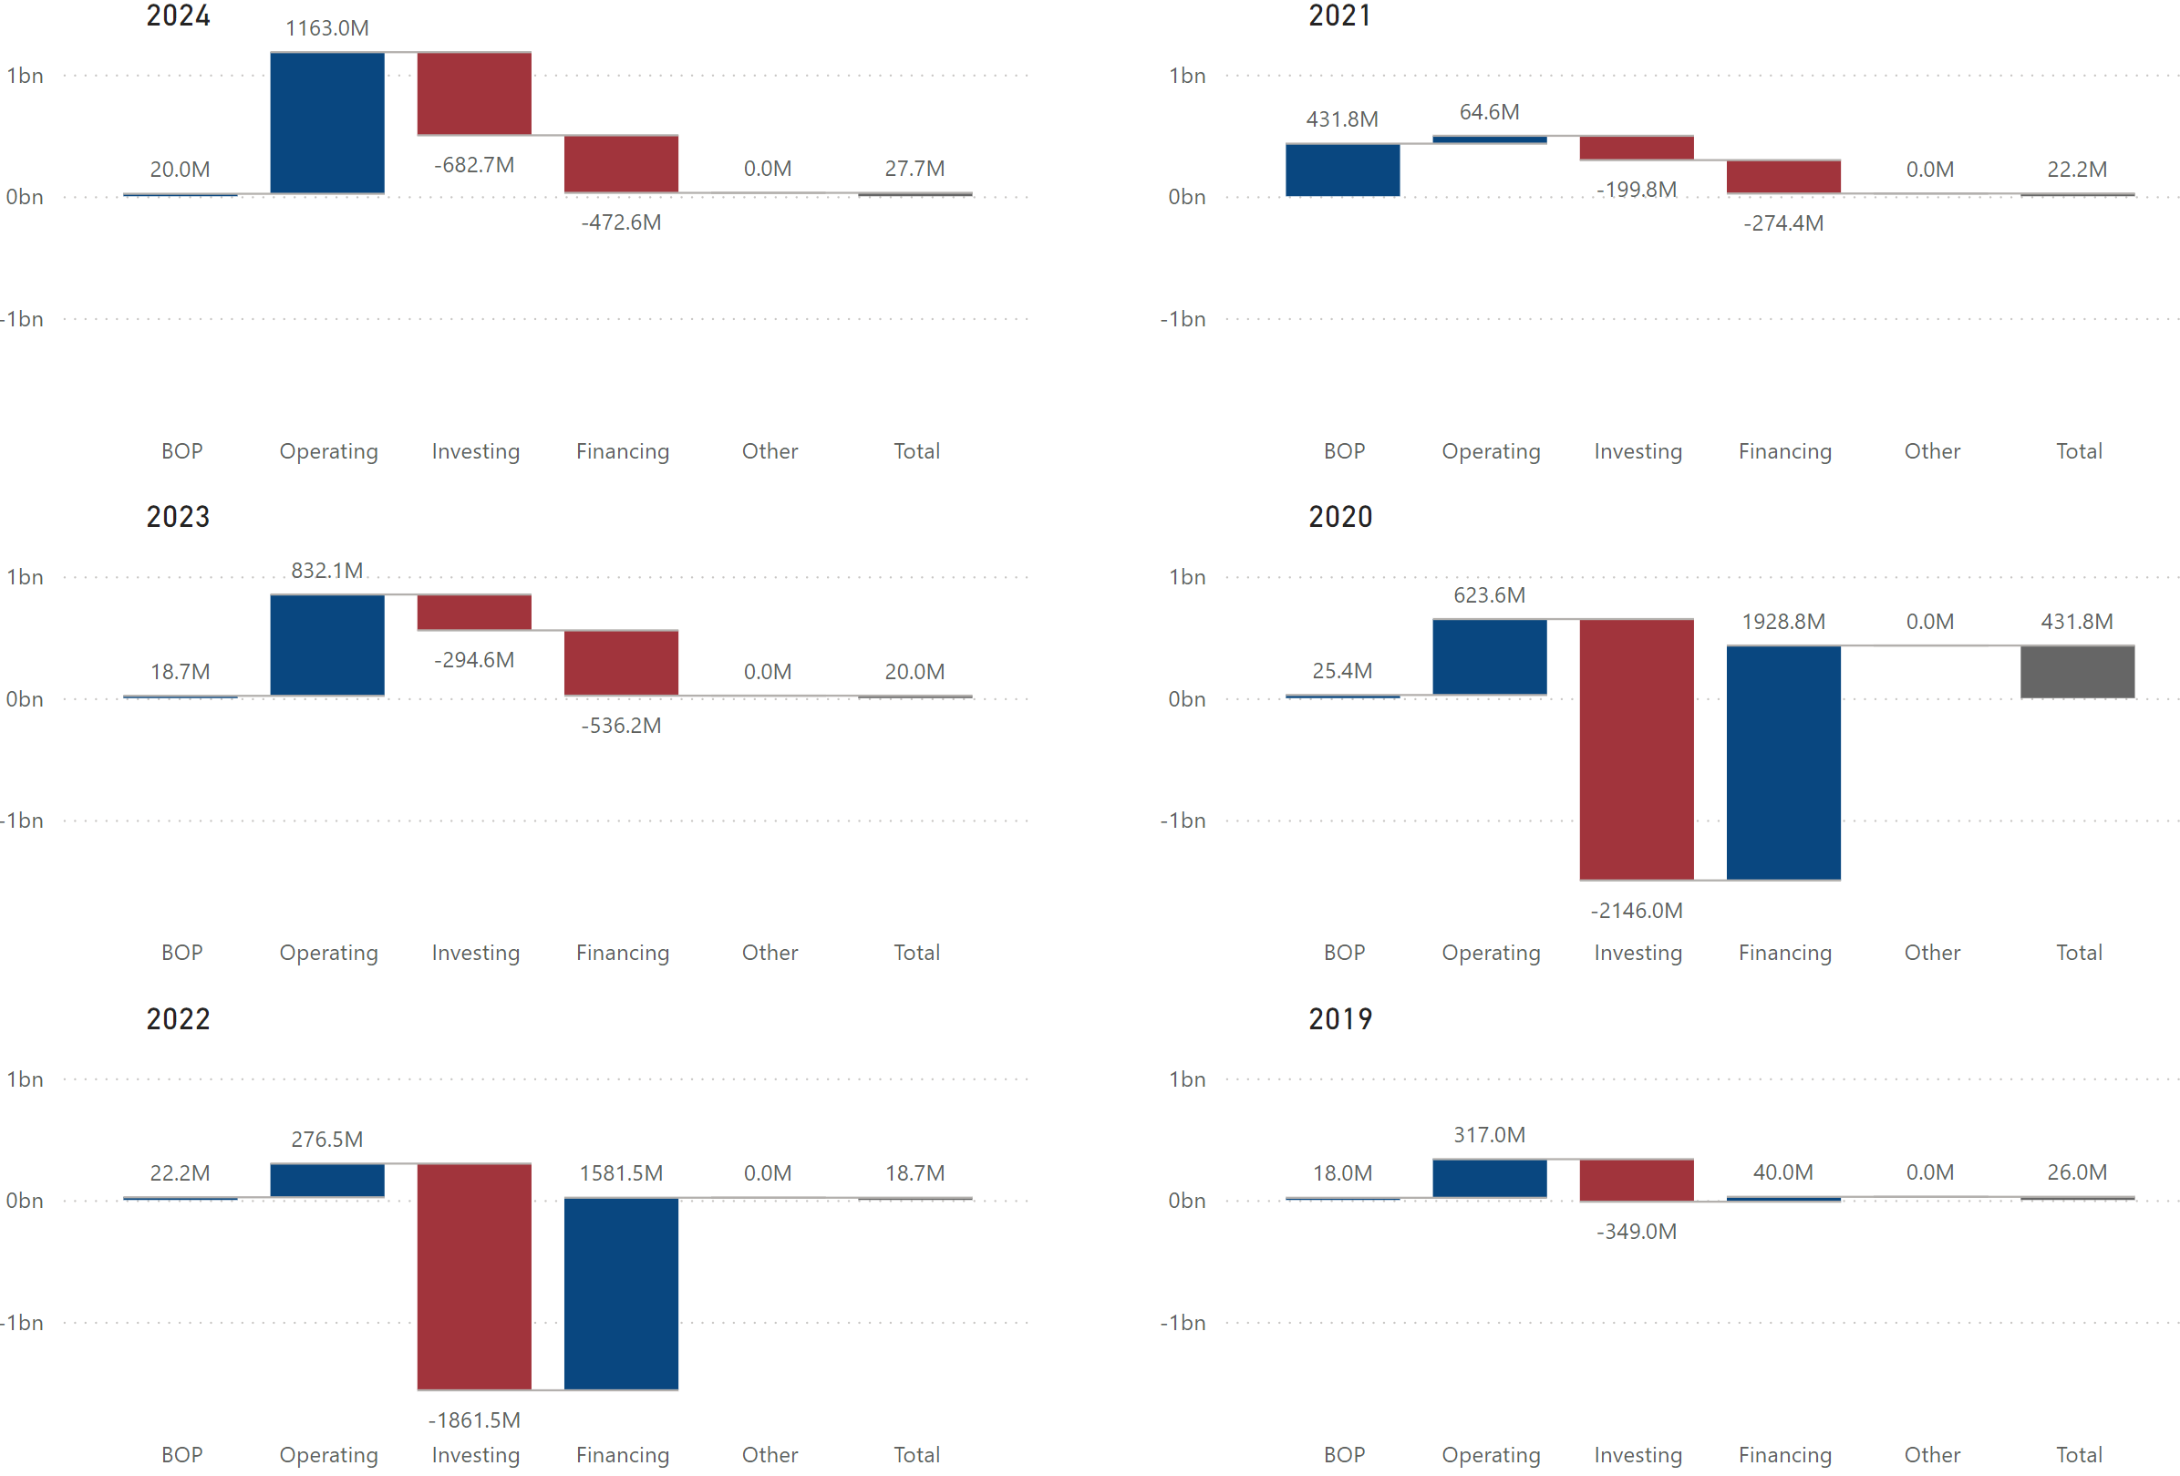

### Cash Flow Chart - Relative to Sysco

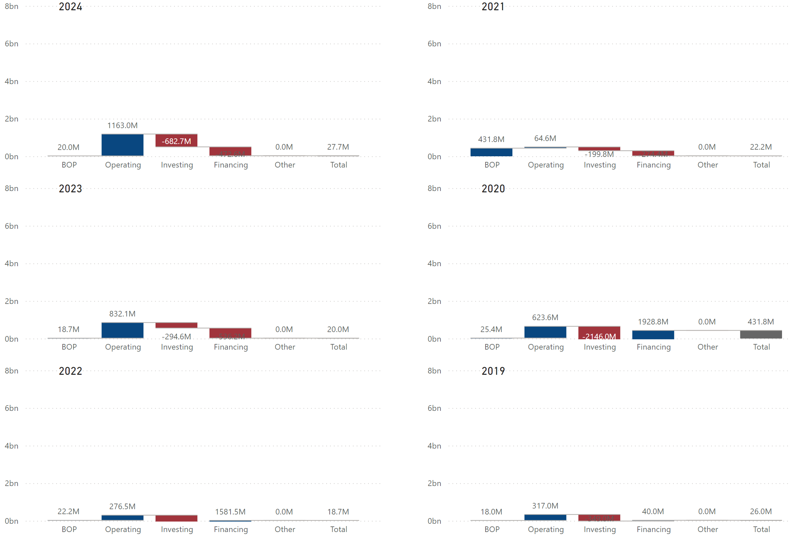

### Historical Financial Ratios



### Long-Term Debt (Most Recent Years)

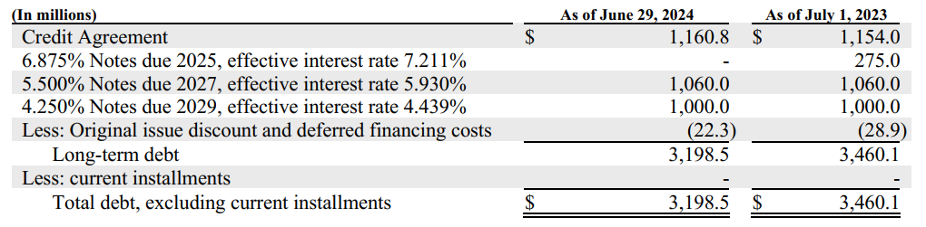

### Maturities of Long-Term Debt / Estimated Debt Service Requirements

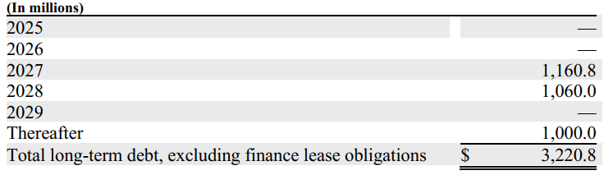

### Key Financial Insights

* (BL) ***The company’s total asset structure is almost 50% current assets and 50% non-current assets.***
  + Like Sysco and US Foods, the company’s current assets mainly consist of accounts receivable and inventories, while its non-current assets mainly consist of PP&E and goodwill*¹*.
* (BL) ***The company’s capital structure is similar to US Foods’ but differs from Sysco’s***.
  + The company’s equity primarily consists of additional paid-in capital and retained earnings*¹*. Since the company does not hold any treasury stock, its capital structure (liabilities & equity) resembles US Foods’ more than Sysco’s.

* (PL) ***The company’s COGS % is higher than Sysco’s and US Foods’, leading to the lowest profitability among the three companies***.
  + The company’s revenues primarily come from its Foodservice (about 50%) and Convenience segments (about 40%)*²*. The company’s lowest profitability among the three companies is mainly driven by the Convenience segment, which has an adjusted EBITDA Margin of around 1.3%*²*. The adjusted EBITDA Margin for the Foodservice segment is approximately 3%*²*. Sysco does not report adjusted EBITDA by segment, but its overall adjusted EBITDA margin is around 5%, indicating that Sysco’s broadline operations are more profitable and/or efficient than PFG’s.
* (CF) ***It appears that the company financed its investments in 2020 and 2022***.
  + The company’s negative cash flows from financing activities in 2022 were primarily due to net borrowings under ABL Facility, and its positive cash flows from investing activities were primarily due to business acquisitions.
  + The company’s negative cash flows from financing activities in 2020 were primarily due to net proceeds from issuance of common stock, and its positive cash flows from investing activities were primarily due to business acquisitions.

*¹ Refer to* ***PFG’******historical balance sheet*** *in the supplemental data section.  
² Refer to* ***PFG’ KPIs*** *in the supplemental data section.*

Final Notes

**The foodservice distribution industry** is characterized by low profit margins due to its cost-plus pricing model. Consequently, companies in this sector tend to prefer individual restaurant customers over multi-unit customers, hospitals, schools, etc. This preference is driven by the fact that individual restaurants typically utilize more value-added services – one of their highest-margin offerings - and are more likely to purchase private label products, which are more profitable than national brands.

Given the nature of retail-based businesses, companies often focus on maintaining their presence or entering new markets with higher margins. Sysco, for example, recently acquired Edward Don to expand its presence into restaurant equipment and supplies space, which are more profitable than the traditional broadline goods sector.

**Sysco Corporation** is the largest foodservice distributor in the industry. Despite its high financial leverage, driven by treasury stock largely offsetting its significant retained earnings, it remains financially stable, supported by favorable debt terms and healthy cash flow. As a member of the dividend aristocrats, the company is committed to returning value to shareholders through dividends, allocating approximately 50% of its net income to this purpose. Additionally, it has been acquiring smaller businesses from time to time to expand its operations and market presence.

**US Foods Corp.**, the second largest foodservice distributor, relies more heavily on M&A as a growth strategy. This is reflected in its higher proportion of non-current assets compared to Sysco, with goodwill accounting for 43.2% of total assets. This indicates the company is actively acquiring businesses to expand its market presence. The company has a lower net income margin than Sysco, which may be attributable to its smaller scale, lower pricing power, or reduced operational efficiencies. Additionally, its higher interest rates and shorter debt maturities suggest that the market perceives US Foods as having greater credit risk than Sysco.

**Performance Food Group**’s capital structure is more similar to US Foods, with equity consisting primarily of additional paid-in capital and retained earnings, and no treasury stock. Its Convenience segment, one of the largest foodservice and wholesaler consumer products distributors in the convenience retail industry, accounts for over 40% of its total revenues. However, the significantly low profitability of this segment contributes to the company’s overall profitability being the lowest among the three companies.

# Supplemental Data

## Sysco Corporation

### KPIs by Segment



### Historical Balance Sheet with % of Total



### Historical Balance Sheet with % Change



Historical P/L Statement



### Historical Equity Statement

(In thousands)

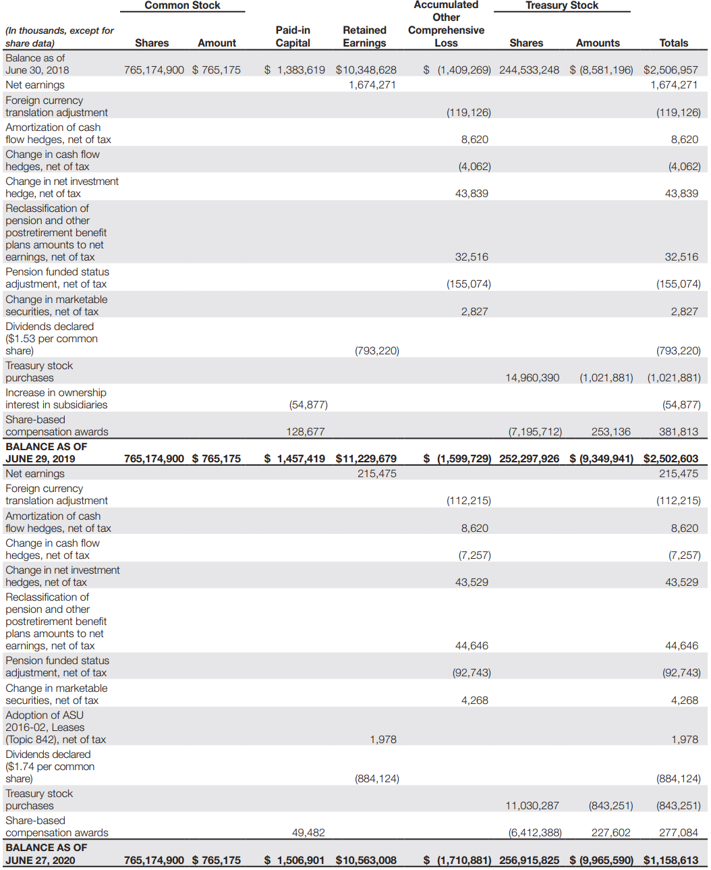

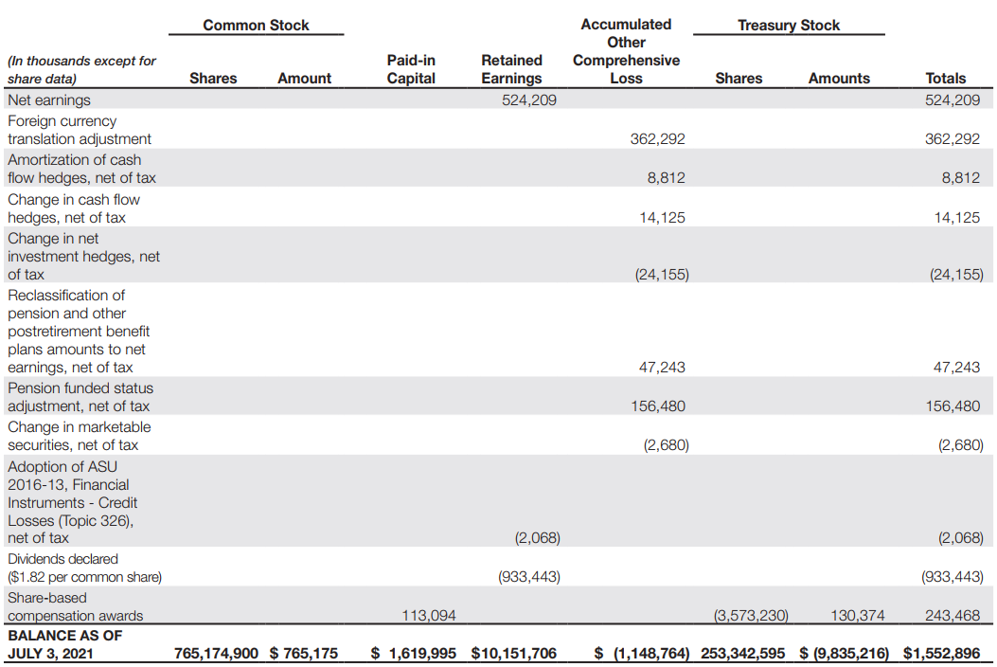

(In millions)

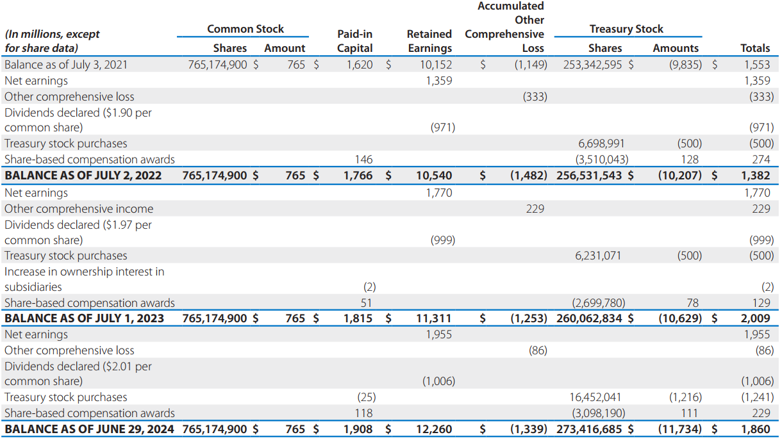

### Historical Cash Flow Statement



## US Foods

### KPIs by Segment

n/a

### Historical Balance Sheet with % of Total



### Historical Balance Sheet with % Change



Historical P/L Statement



### Historical Equity Statement

(In millions)

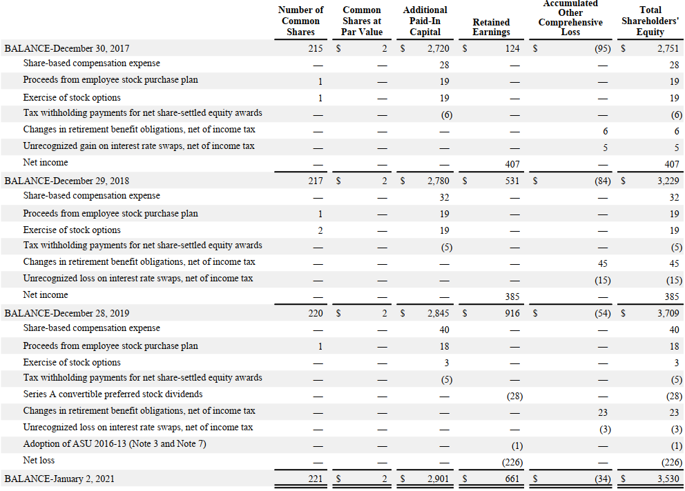

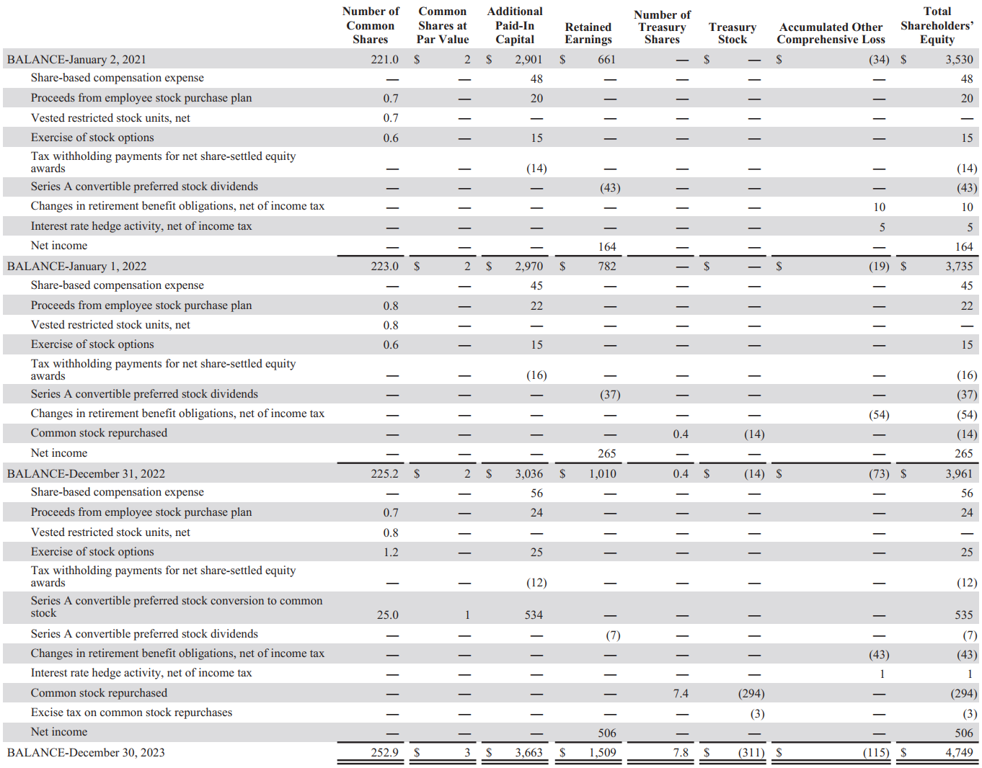

### Historical Cash Flow Statement



## Performance Food Group

### KPIs by Segment



### Historical Balance Sheet with % of Total



### Historical Balance Sheet with % Change



Historical P/L Statement



### Historical Equity Statement

(In millions)

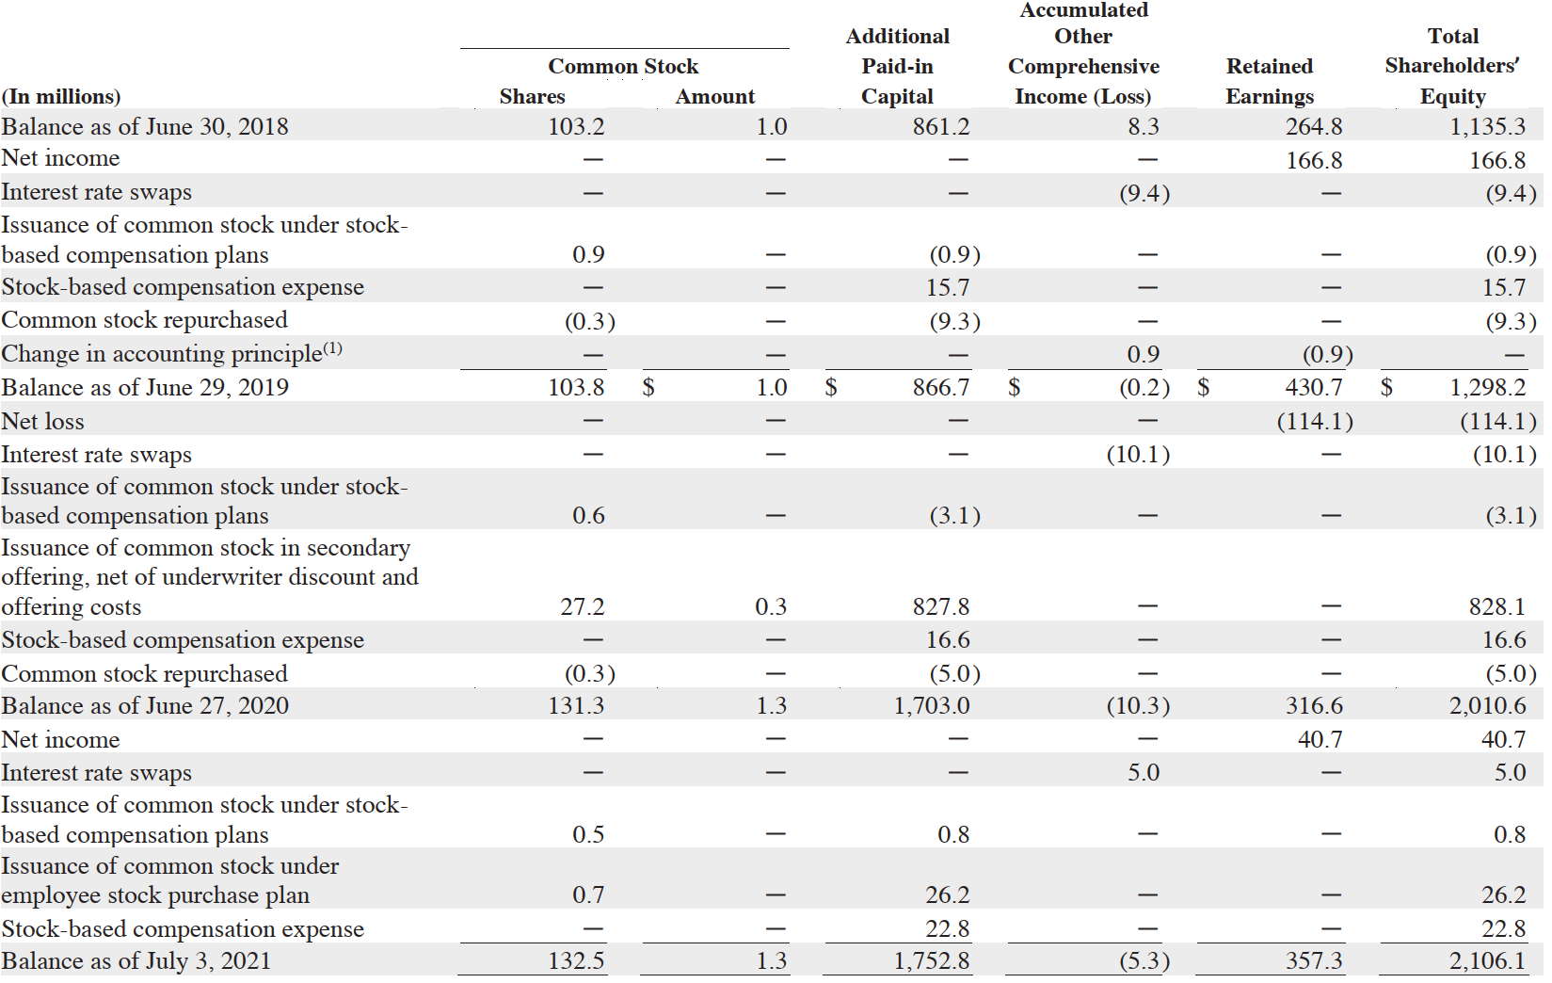

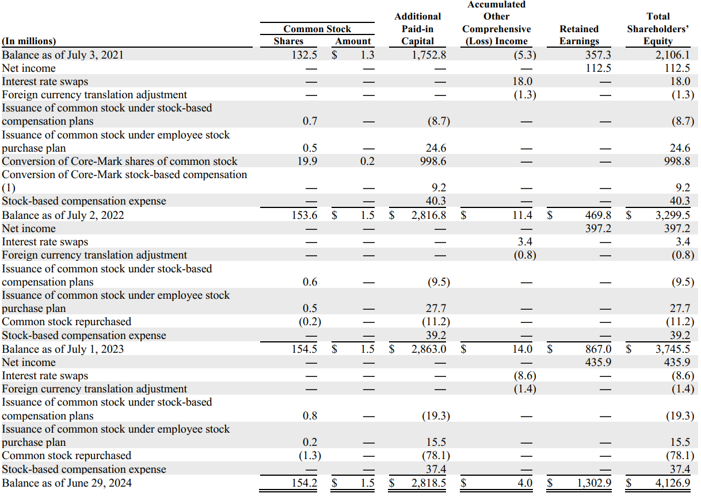

### Historical Cash Flow Statement



## DuPont Analysis (2024)

DuPont Analysis is a financial performance framework that helps break down a company’s ROE into 6 key components. This analysis provides insights into the drivers of a company’s financial performance, helping stakeholders understand how each factor contributes to the overall return.

### Sysco Corporation



### US Foods

n/a

### Performance Food Group

DuPont Analysis (2023)

### Sysco Corporation



### US Foods



### Performance Food Group



## Financial Ratios Formula

### Activity Ratios

#### Receivables Turnover

Meaning: The efficiency of a company in collecting its receivables  
Formula: Revenue / Average Receivables

#### DSO

Meaning: The average number of days a company takes to collect its receivables from clients  
Formula: 365 / Receivables Turnover

#### Inventory Turnover

Meaning: The efficiency of a company in terms of inventory management  
Formula: COGS / Average Inventory

#### DIO

Meaning: The average inventory processing period  
Formula: 365 / Inventory Turnover

#### Payables Turnover

Meaning: The efficiency of a company in allowing its credit to suppliers  
Formula: Purchases / Average Payables

#### DPO

Meaning: The average number of days a company takes to pay its suppliers  
Formula: 365 / Payables Turnover

#### Cash Conversion Cycle

Meaning: The number of days a company takes to convert its investments in inventory and other resources into cash flows from sales

Formula: DSO + DIO - DPO

#### Fixed Assets Turnover

Meaning: The efficiency of a company in utilizing its fixed assets to generate revenue  
Formula: Revenue / Average Fixed Assets

#### Working Capital Turnover

Meaning: The efficiency of a company in managing its working capital (current assets – current liabilities)  
Formula: Revenue / Average Working Capital

#### Total Assets Turnover

Meaning: The efficiency of a company in utilizing its total assets to generate revenue  
Formula: Revenue / Average Total Assets

#### Equity Turnover

Meaning: The efficiency of a company in utilizing equity to generate revenue  
Formula: Revenue / Average Total Equity

### Liquidity Ratios

#### Current Ratio

Meaning: The ability of a company to meet current liabilities (with total current assets)  
Formula: Current Assets / Current Liabilities

#### Quick Ratio

Meaning: The ability of a company to meet current liabilities (with total current assets, excluding inventory and prepaid expenses)

Formula: (Total Current Assets – Inventory – Prepaid Expenses) / Current Liabilities

#### Cash Ratio

Meaning: The ability of a company to meet current liabilities (with cash only)  
Formula: Cash / Current Liabilities

#### Defensive Interval

Meaning: The number of days a company can cover its average daily expenses with the use of current liquid assets only

Formula: (Total Current Assets – Inventory – Prepaid Expenses) / Average Daily Expenditure

### Solvency Ratios

#### Debt-to-Equity

Meaning: Debt as a percentage of total equity  
Formula: Total Debt / Total Equity

#### Debt-to-Capital

Meaning: Debt as a percentage of total capital  
Formula: Total Debt / (Total Debt + Total Equity)

#### Debt-to-Assets

Meaning: Debt as a percentage of total assets  
Formula: Total Debt / Total Assets

#### Financial Leverage

Meaning: An indicator of a company’s debt financing usage  
Formula: Average Total Assets / Average Total Equity

#### Interest Coverage

Meaning: The ability of a company to cover its interest expenses  
Formula: EBIT (Operating Income) / Interest Payments

### Profitability Ratios

#### Gross Profit Margin

Meaning: Gross profitability as a percentage of total revenue  
Formula: (Revenue – COGS) / Revenue

#### Operating Profit Margin

Meaning: Operating profitability (before interest and tax) as a percentage of total revenue  
Formula: Operating Income (EBIT) / Revenue

#### Pre-Tax Profit Margin

Meaning: Operating profitability (before tax) as a percentage of total revenue  
Formula: EBT / Revenue

#### Net Profit Margin

Meaning: Net profitability as a percentage of total revenue  
Formula: Net Income / Revenue

#### ROA (Return on Assets)

Meaning: Net profitability (excluding interest and tax) as a percentage of total invested funds  
Formula: Net Income / Average Total Assets

#### Operating ROA

Meaning: Net profitability (including interest and tax) as a percentage of total invested funds  
Formula: Operating Income (EBIT) / Average Total Assets

#### ROC (Return on Total Capital)

Meaning: Operating profitability as a percentage of total capital  
Formula: Operating Income (EBIT) / Average Total Capital

#### ROE (Return on Equity)

Meaning: Net profitability as a percentage of total equity  
Formula: Net Income / Average Equity

### Valuation Ratios

#### EPS (Earnings Per Share)

Meaning: Income earned per 1 common share outstanding

Data is obtained from each company’s financial statement.

PE Ratio  
Meaning: The price that investors are willing to pay per $1 of earnings

Data is obtained from Macrotrends.

Dividend Payout Ratio (DPR)  
Meaning: The measure of dividends paid out to shareholders relative to the company’s net income

Formula: Dividends Paid to Common Shareholders / Net Income

Dividend Yield  
Meaning: The ratio that shows how much a company pays out in dividends each year relative to its stock price

Formula: Dividends Paid to Common Shareholders / Net Income